

**<CRYPTOCURRENCY PRICE PREDICTION USING PATTERN SEARCHING ALGORITHMS>**

A DISSERTATION SUBMITTED TO COVENTRY UNIVERSITY FOR THE DEGREE OF BACHELOR OF ENGINEERING IN THE FACULTY OF ENGINEERING, ENVIRONMENT AND COMPUTING

By

**MR ABDUSSAMAD ASJID SALEEM**

SID – **11778028**

Supervisor – **Chris Bass**

December 2024

## Declaration

No portion of the work presented in this thesis has been submitted in support of an application for another degree or qualification of this or any other universirt or institute of learning.

## Acknowledgements

I dedicate this work to Dr Dianabasi and all other professors at Coventry University for developing my interest and understanding for machine learning algorithm theory. I have also learned a lot from Andrew Ng’s Machine Learning course on YouTube. He has helped me understand core concepts of machine learning algorithms which has helped me improve accuracy and efficiency of Cryptocurrency price prediction models. I also want to thank Meet Nagadia, an AI Engineer for his contributions to Cryptocurrency price prediction concept on GitHub. His GitHub contribution has helped me understand core concepts of dataset and data preprocessing techniques used in this project.

## Authors Background

I am a student of Computer Hardware and Software Engineering. I am passionate about learning new machine learning concepts and algorithms. I am always experimenting ways to improve accuracy in already existing projects related to machine learning. Cryptocurrency has always fascinated me in terms of technology used for its regulation and their unique decentralized financial system. I have combined my passion for machine lerning and Cryptocurrency in this project to create an optimized algorithm for prediction of unstable Cryptocurrency market.

## Copyright

Copyright in the text of this document rests with the Author. Copies (by any process) either in full, or of extracts, may be made only in accordance with instructions given by the Author and lodged in the Coventry University Lanchester Library. Details may be obtained from the Librarian. This page must form part of any such copies made. Further copies (by any process) of copies made in accordance with such instructions may not be made without permission (in writing) of the Author.

The ownership of any intellectual property rights which may be described in this document rests with Coventry University, subject to any prior agreement to the contrary, and may not be made available for use by third parties without the written permission of the University, which will prescribe the terms and conditions of any such agreement.

List of Figures

**Fig 1 Financial Time Series Methodology 10**

**Fig 2 Project Flowchat 12**

**Fig 3 Dataset Rows 13**

**Fig 4 Bitcoin Open Price vs Close Price 14**

**Fig 5 Bitcoin Monthly High & Low Prices 14**

**Fig 6 Bitcoin OCHL 15**

**Fig 7 Dataset Description 16**

**Fig 8 Minmax Normalized Data 17**

**Fig 9 Bitcoin Prices by Month (Highest) 18**

**Fig 10 Bitcoin Yearly Analysis Chart 18**

**Fig 11 Training vs Testing Data Split 19**

**Fig 12 LSTM Architecture 21**

**Fig 13 GRU Architecture 22**

**Fig 14 LSTM Model Training vs Validation Loss 30**

**Fig 15 LSTM Predicted vs Actual Value Graph 31**

**Fig 16 GRU Training vs Validation Loss 32**

**Fig 17 GRU Predicted vs Actual Values Graph 33**

Table of Contents

Declaration 1

Acknowledgements 1

Authors Background 1

Copyright 1

Glossary 7

Chapter 1: Introduction 11

Background 11

Motivation for Study 11

Problem Statement 12

Objectives 12

Research Questions 13

Scope of the Study 14

Chapter 2: Literature Review 16

Overview of Cryptocurrencies 16

Factors Influencing Cryptocurrency Prices 16

Traditional Price Prediction Models 16

Machine Learning in Financial Time Series Prediction 17

Pattern Searching Algorithms 18

Summary 19

Chapter 3: Research Methodology and Preliminary Design 20

Overview 20

Data Collection 21

Exploratory Data Analysis (EDA) 22

Data Preprocessing 24

Feature Selection 29

Machine Learning Models Used 29

LSTM Model 30

GRU Model 32

Evaluation Metrics 34

1. Mean Absolute Error (MAE) 34

2. Mean Squared Error (MSE) 34

3. Root Mean Squared Error (RMSE) 35

4. R-squared (R²) 35

Tools and Technologies 35

Chapter 4: Implementation / Data Collection / Results 37

Data Preparation 37

Model Architecture 37

Model Training 37

Model Validation and Testing 39

Hyperparameter Tuning 39

Chapter 5: Discussion & Analysis 42

Presentation of Results 42

LSTM Results 42

GRU Result 44

Comparison of Results 46

Implications for Cryptocurrency Prediction 47

Chapter 6: Conclusion & Recommendations for Future Work 49

Summary of Findings 49

Contributions to the field 49

Recommendations for Future Work 50

APA References 52

Appendix A: Certificate of Ethical Approval 56

Appendix B: Complete Code 57

Appendix C: Risk Assessment 83

Appendix D: Gantt Chart 84

Appendix E: Notes 85

# Glossary

**A**

**ARIMA (Autoregressive Integrated Moving Average):**  
A statistical model used for analyzing and forecasting time-series data, particularly suited for linear patterns.

**B**

**Bitcoin:**  
The first decentralized cryptocurrency introduced in 2008, which operates on a peer-to-peer network without a central authority.

**Blockchain:**  
A decentralized digital ledger technology that records transactions across multiple computers in a secure and tamper-proof manner.

**C**

**Cryptocurrency:**  
A digital or virtual currency that uses cryptography for security and operates on blockchain technology, enabling decentralized transactions.

**D**

**Data Preprocessing:**  
The process of transforming raw data into a structured format suitable for machine learning models by handling missing values, normalization, and noise reduction.

**Dropout Regularization:**  
A technique used in neural networks to prevent overfitting by randomly setting a fraction of input units to zero during training.

**E**

**Exploratory Data Analysis (EDA):**  
The initial step in data analysis aimed at summarizing the main characteristics and visualizing trends in a dataset.

**F**

**Feature Selection:**  
The process of identifying and using the most relevant variables in a dataset to improve the performance of a machine learning model.

**G**

**GRU (Gated Recurrent Unit):**  
A type of recurrent neural network (RNN) that addresses the vanishing gradient problem with simpler architecture compared to LSTM, using reset and update gates.

**H**

**Hyperparameter Tuning:**  
The process of optimizing model parameters (e.g., learning rate, batch size) to improve performance on validation data.

**L**

**LSTM (Long Short-Term Memory):**  
An advanced RNN designed to learn long-term dependencies in sequential data using memory cells and gating mechanisms.

**Loss Function:**  
A mathematical function that quantifies the difference between predicted and actual values during model training, guiding parameter updates.

**M**

**Machine Learning:**  
A branch of artificial intelligence focused on creating systems that learn patterns from data to make predictions or decisions.

**Mean Absolute Error (MAE):**  
An evaluation metric for machine learning models that calculates the average absolute differences between predicted and actual values.

**Mean Squared Error (MSE):**  
An evaluation metric that measures the average squared differences between predicted and actual values, penalizing larger errors.

**Min-Max Normalization:**  
A feature scaling technique that transforms data values to a specific range, often [0, 1], to eliminate bias in machine learning models.

**R**

**Recurrent Neural Network (RNN):**  
A class of neural networks designed to process sequential data by retaining information from previous inputs.

**Root Mean Squared Error (RMSE):**  
A metric that measures the square root of the average squared differences between predicted and actual values, expressed in the same units as the target variable.

**R-Squared (R²):**  
A statistical measure that explains the proportion of variance in the dependent variable predictable from the independent variables.

**T**

**Time-Series Data:**  
Data points collected or recorded at successive points in time, often used in forecasting models.

**Transformer Models:**  
Advanced deep learning architectures that use attention mechanisms to focus on relevant parts of the input data, especially effective in capturing long-term dependencies.

**V**

**Validation Loss:**  
The error calculated on a validation dataset, used to monitor a model's performance during training and prevent overfitting.

# Chapter 1: Introduction

## Background

Wei Dai first proposed the idea of cryptocurrencies in 1998, providing a decentralized method of safe inter-personal payments. The introduction of Bitcoin as a payment method in 2008 marked the beginning of this idea. Bitcoin wasn't a commonly used transaction source at first, but it eventually proved valuable. In 2008, when the biggest financial crisis that the world had ever seen took place, a need for a new secure and decentralized payment system was crucially felt. In the same year, a research paper was published by an anonymous individual *Bitcoin: A Peer-to-Peer Electronic Cash System* [(Satoshi Nakamoto, 2008)](https://bitcoin.org/bitcoin.pdf)*.* Due to its safe, secure, and decentralized concept; cryptocurrencies became extremely popular. After bitcoin, several other cryptocurrencies were also launched. With several options available, it has become difficult for investors to predict which cryptocurrency they should invest in and which will bring them the most profit.

## Motivation for Study

This form of decentralized payment system utilizes new technologies; blockchain networks and improved machine learning algorithms to provide more speed, security, and accessibility for each of its users. The rise of popularity in cryptocurrencies also opens the way for advanced price predictors for investors. Using advanced machine learning algorithms and finding recurring patterns affecting the crypto market, these crypto price predictor tools can be made more accurate and profitable. Thousands of investors are interested in new and improved crypto price detectors that can make profitable decisions for them based on facts and recurring patterns in the market. The rapid growth in machine learning algorithms and AI can also benefit cryptocurrency price predictors to become more trustworthy and accurate.

Trading strategies have been made easier when machine learning algorithms are involved. Algorithms can search for patterns in historical data that humans cannot detect with the human eye. By inputting historical data, the algorithms can analyze historical patterns, and traders and investors are globally enabled to leverage various other models to have valuable information to help their decision-making processes, these algorithms allow traders to become better informed in real-time trading with possibly higher returns.

GRU (gated recurrent network) and LSTM (Long Short-Term Memory) are the machine learning algorithms implemented in this project. Both algorithms are recurrent neural networks (RNNs). RNN has been implemented to forecast cryptocurrency data as both algorithms are implemented for time-series analyses. Numerous machine-learning algorithms have been successful for trading. Regression models can capture complex patterns in historical data.

## Problem Statement

In the cryptocurrency market, existing algorithms and methods are insufficient to predict future trends accurately. Most investors face significant risks due to imperfect automated systems in predicting the crypto market. This is mainly due to inefficient and unreliable algorithms for creating these applications. By analyzing this problem, accuracy in price predictions can be achieved to help stakeholders invest responsibly and profitably in the crypto market. This project aims to implement algorithms that can make cryptocurrency predictions more accurate and reduce risks to investors. By using advanced machine learning algorithms and models, it is possible to achieve this task.

## Objectives

* To compare different machine learning models related to cryptocurrency price predictions.
* To improve machine learning algorithms like GRU and LSTM to accurately predict cryptocurrency price fluctuations.
* To create an automated cryptocurrency prediction model incorporating unique features affecting the cryptocurrency market.
* To test the accuracy of the finished model using real-time cryptocurrency market data.
* To improve cryptocurrency price predictions using advanced machine learning algorithms and help make accurate and profitable decisions for investors interested in the cryptocurrency market.

## Research Questions

* What are the main factors affecting cryptocurrency price changes?
* What problems do current tools and methods have in predicting cryptocurrency price changes?
* How can machine learning models like GRU and LSTM be improved to better predict cryptocurrency prices?
* What specific features in cryptocurrency data can be used to make prediction models more effective?
* How well does the new prediction model work when tested with actual cryptocurrency data, and how can it help investors make better decisions?

## Scope of the Study

The scope of this study focuses on several key areas affecting cryptocurrency price predictions using pattern searching algorithms.

* **Data Analysis:** The study will analyze real-time cryptocurrency data including price fluctuations, market trends, and other recurring patterns that affect prices of cryptocurrencies.
* **Advanced Machine Learning Techniques:** Using advanced machine learning models like GRU and LSTM, this project will focus on improving the accuracy and effectiveness of automated prediction models in forecasting cryptocurrency prices.
* **Refining Prediction Model:** The main objective is to improve cryptocurrency price predictions using accurate machine learning models and by refining existing prediction algorithms.
* **Real-Time Data:** This project will use real-time data to ensure its effectiveness and accuracy in predicting cryptocurrency prices.
* **Market Factors:** This project will involve studying various market factors that are responsible for cryptocurrency price fluctuations.
* **Limitations:** This project will analyze the limitations of current prediction tools and algorithms and try to solve the challenges that are negatively affecting price predictions.
* **Stakeholders:** The project will focus on providing reliable Cryptocurrency price-predicting solutions for independent investors and traders to help them make profitable, accurate, and informed decisions. This will also help developers in improving machine learning algorithms for predicting cryptocurrencies.
* **Future Goals:** The project will explore how advanced machine learning algorithms can be used to help investors in cryptocurrency trading strategies and assist in the development of more advanced automated systems for the cryptocurrency price prediction market.

# Chapter 2: Literature Review

## Overview of Cryptocurrencies

Cryptocurrencies have brought an advanced and unique financial system by introducing decentralized, blockchain, and machine learning-based platforms for all types of transactions. Bitcoin was the first application of this financial system that brought an influx of several new digital currencies competing for the top position. The unpredictable fluctuation in cryptocurrency prices introduces new challenges for simple price predictors. There is a need for advanced machine learning models optimized to tackle these challenges, *"The Blockchain Revolution: An Analysis of Emerging Technologies"* [(AG Gad & DT Mosa, 2022)](https://www.sciencedirect.com/science/article/pii/S1319157822000891), the Cryptocurrency price market requires advancements in machine learning algorithms to accurately predict price fluctuations.

## Factors Influencing Cryptocurrency Prices

This study focuses on algorithmic and data-related factors extracted from past price prediction data excluding external factors such as sentiments or news. Cryptocurrency prices show unpredictable behavior which is difficult to accurately analyze. This makes them incompatible with conventional linear regression models. The uncertain factors of Cryptocurrency prices require advanced machine learning models capable of processing this constantly changing data. The importance of advanced machine learning algorithms for analyzing such uncertain data, emphasizes that conventional models fail to account for frequent real-time changes in Cryptocurrency price patterns, [(C Schittenkopf & G Deco, 1997)](https://ieeexplore.ieee.org/abstract/document/618950).

## Traditional Price Prediction Models

Conventional predictive models, such as ARIMA (Autoregressive Integrated Moving Average) and EMA (Exponential Moving Average) have been frequently used in Cryptocurrency markets due to their ease of use. These conventional models have a drawback in measuring fluctuations of Cryptocurrencies since they are best suited for tasks involving linear regression. The Cryptocurrency market is highly volatile, the traditional models do not have the advanced algorithms to measure uncertain price fluctuations making them a risk for investors, [(AM Khedr & I Arif, 2021)](https://onlinelibrary.wiley.com/doi/abs/10.1002/isaf.1488), the algorithms used in these traditional models fail to accurately predict the alternating market conditions in Cryptocurrency. Therefore, in this field, researchers are focusing on advanced machine learning models (LSTM, GRU) to accurately predict price fluctuations. LSTM and GRU offer advanced machine-learning techniques to measure non-linear data as well.

## Machine Learning in Financial Time Series Prediction

In the Cryptocurrency field, advanced machine learning methods, particularly deep learning algorithms have proved to be extremely effective in financial time series predictions. Long Short-Term Memory (LSTM) and Gated Recurrent Units (GRUs) are advanced variants of deep learning techniques called Recurrent Neural Networks (RNN). LSTM and GRU offer advanced techniques for time series predictions, [(Chen, Weisi & Hussain, 2023)](https://www.researchgate.net/publication/376955171_Deep_Learning_for_Financial_Time_Series_Prediction_A_State-of-the-Art_Review_of_Standalone_and_Hybrid_Models), both LSTMs and GRUs are effective in adapting to dynamic data like cryptocurrency prices while reducing computational demands. These characteristics make them a good fit for handling rapidly changing markets.

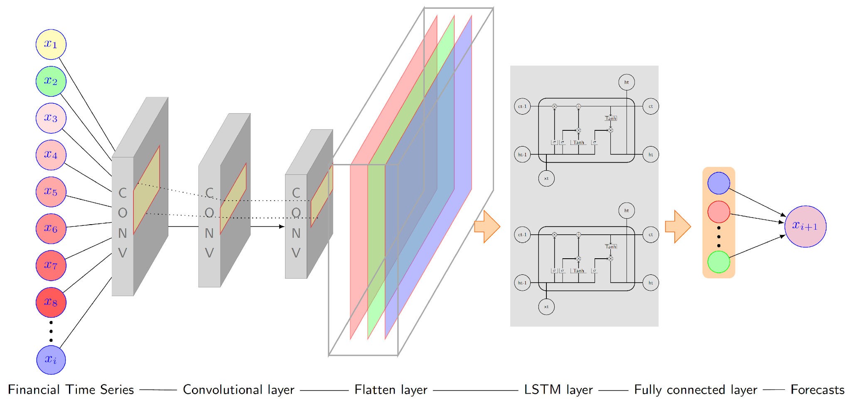

Fig 1 Financial Time Series Methodology

## Pattern Searching Algorithms

Pattern recognition is an important part of financial time series predictions, as it enables machine learning models to extract relevant information from noisy data. Feature extraction techniques are used to preprocess and structure data for machine learning applications. *"*Pattern Recognition in Cryptocurrency Price Time-Series Data" [(I Uzun, 2024)](https://www.mdpi.com/2079-3197/12/7/132) places great importance on the role of advanced feature selection algorithms in identifying unique attributes that affect prediction accuracy.

Combining these techniques with machine learning models improves the ability to detect recurrent patterns and irregularities in real-time data. Principal Component Analysis (PCA) and clustering reduce dimensionality, enabling algorithms to prioritize essential features during training, *"*Time-series data preprocessing: a survey and an empirical analysis*"* [(A Tawakuli, 2024)](https://www.sciencedirect.com/science/article/pii/S2307187724000452), effective preprocessing is important for improving model performance in constantly changing markets.

## Summary

This project highlights the importance of using advanced machine learning models; Long Short-Term Memory (LSTM) and Gated Recurrent Units (GRU. They process alternating sequential data more accurately making them ideal for financial time series predictions. Challenges faced by LSTM and GRU include overfitting, processing noisy data, and measuring frequently changing real-time Cryptocurrency data.

Hyperparameter tuning and regularization are used to improve the accuracy of LSTM and GRU. Additionally, the use of advanced preprocessing methods and pattern recognition techniques can be used to improve the accuracy of machine learning models.

This project addresses these gaps by focusing on improving the accuracy and effectiveness of LSTM and GRU models for cryptocurrency price prediction. By using improved machine learning algorithms and comparing different data inputs, this project aims to greatly improve the accuracy and effectiveness of Cryptocurrency price predictors helping investors make the right decision and minimizing financial loss.

# 

# Chapter 3: Research Methodology and Preliminary Design

## Overview

This chapter discusses the methodologies and approaches utilized with machine learning and deep learning techniques. The methodology comprises all the processes required to train the model. Provided with the complex nature of the cryptocurrency market, a properly structured and objective approach is mandatory to have reliability, replicability, and precision.

Breaking down the project implementation into sub-parts helps in managing the project and the flow gets a lot easier for the execution phase. The project starts with data collection, then a detailed Exploratory Data Analysis (EDA) to understand the data, data preprocessing to prepare the data, feature selection, algorithm selection, and finally creating an architecture with the selected algorithm.

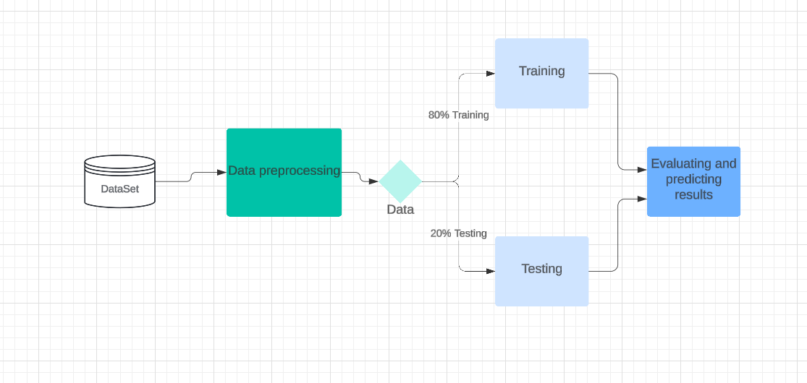

Fig 2 Project Flowchart

The flowchart discussed the project's step-by-step approach and emphasized the weightage of planning and dividing the project into sub-tasks. Initially, the dataset was finalized. Then the data was explored in detail to extract data patterns and understanding of the data. Necessary preprocessing steps were performed to clean, scale, and structure the data. The dataset was then split into training and testing sets as a training set was used for training the model and a test set was used to evaluate the model's performance.

## Data Collection

The data used in this project contains the historical Bitcoin prices over a defined period. The historical data is retrieved from Yahoo Finance. Yahoo Finance is a website that has input cryptocurrency data from CoinMarketCap and is a highly accurate and precise dataset. Key attributes of the dataset include date, open price, close price, low, high, and volume. Date which shows the Bitcoin prices of that day, Open price is the first price of the day, High is the highest traded price of the day, Low is the lowest traded price of the day, Close/Adj Close is the final Bitcoin price of the day, Volume is the total amount of Bitcoin traded in a day. These elements are essential for predictions in financial analysis as outlined in [(Nakamoto, 2008)](https://bitcoin.org/bitcoin.pdf).

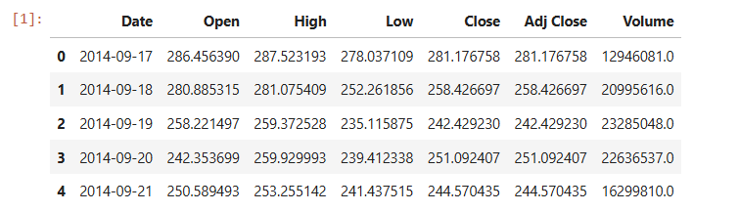

Fig 3 Dataset Rows

## Exploratory Data Analysis (EDA)

After the data collection, data understanding is very important. Data may be corrupted, or it can have noise, outliers, redundancy, etc. Having a short and effective analysis to understand the trends, structure, and patterns in the dataset is important. Noise refers to irrelevant or random data that does not represent any pattern or relationship between entities. The model does not learn anything with the noisy data due to no proper patterns, hence, this affects the performance of the model. In a time series dataset, noise refers to irregularities that deviate from the underlying pattern or the data that cannot be explained or predicted by the model. Some sources of noise include measurement errors, external disturbance, and intrinsic randomness. The dataset quality can be improved after detailed EDA. It also helps in:

1. Removing the duplication in the data.
2. Understating the relationship between different features.
3. Dataset detailed evaluation using statistical measurements.

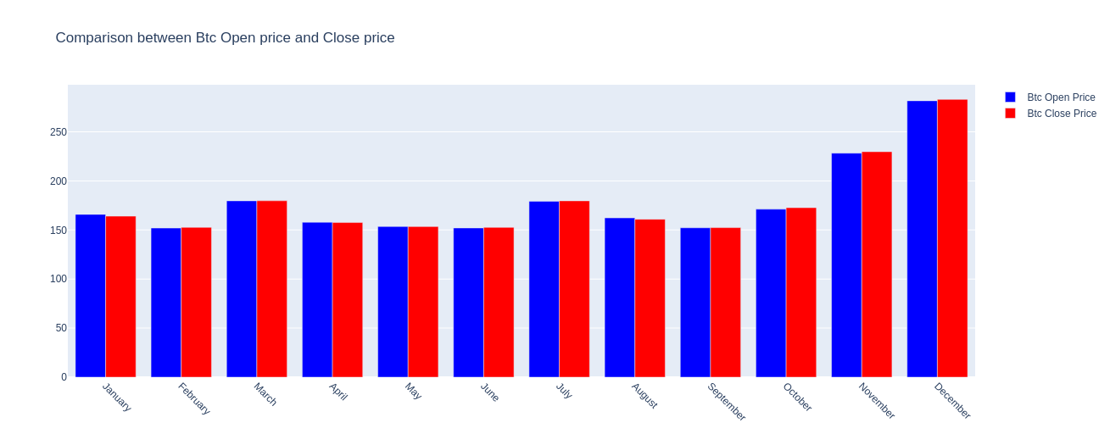

Fig 4 Bitcoin Open Price vs Close Price

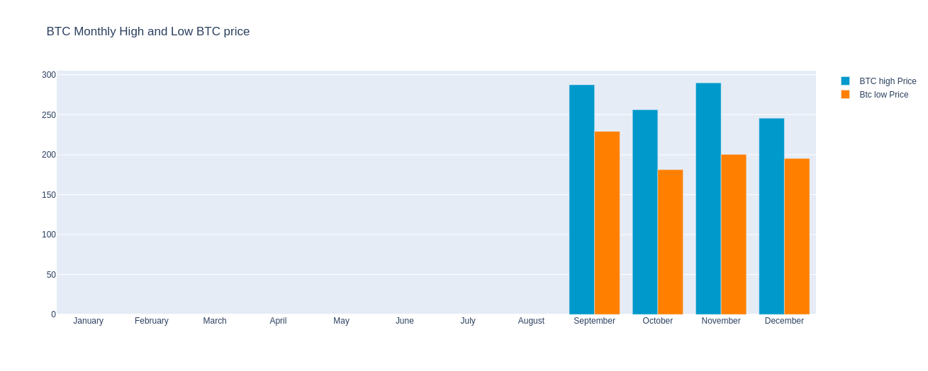

Fig 5 Bitcoin Monthly High & Low Prices

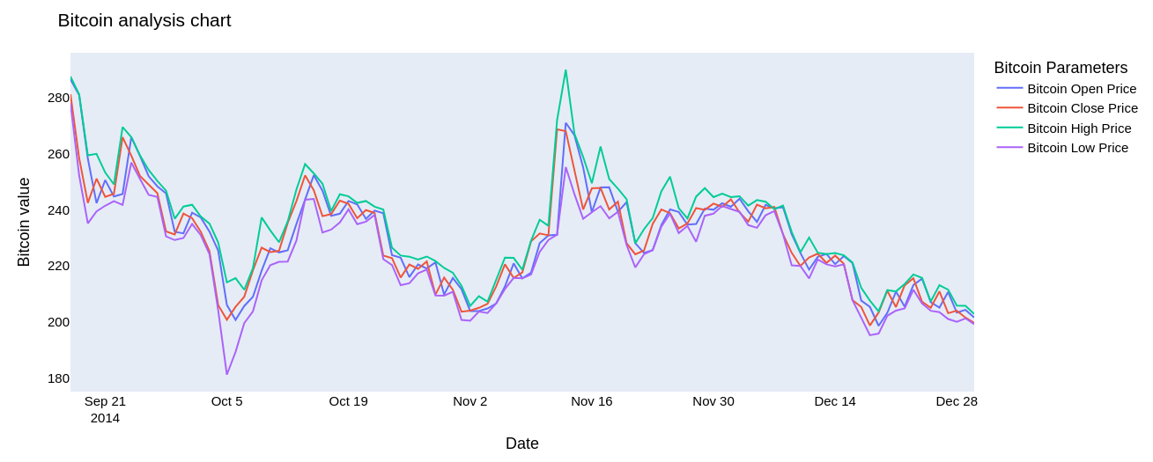

*The line chart plot shows a detailed analysis covering Bitcoin’s open, high, low, and close prices over a specific period. The nonlinear dynamics in financial time series data were analyzed, building on methods suggested by (Schittenkopf & Deco, 1997).*

Fig 6 Bitcoin OCHL

## Data Preprocessing

In machine learning, the performance of the model mainly depends on the quality of the data used during training. While the focus is on algorithms, data preprocessing is extremely important, compromising on this step affects the performance of the model. Transforming raw data into useful features using different techniques is done in the preprocessing step. This step plays a critical part in enhancing the performance of the model. Data that is preprocessed well usually generates better results. This project’s data preprocessing is mainly categorized into 3 phases: Data inspection, handling **missing values**, and **normalization.**

1. **Data inspection** involves checking the dataset's appearance. Understanding the data pattern and data behavior solves half of the problem. Analyzing the data early on helps in overcoming potential challenges and solves a significant part of the problem. Pandas library easily manipulates data operations for smooth data inspection.

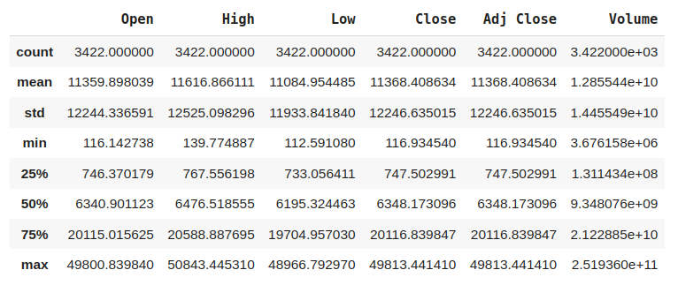

Fig 7 Dataset Description

1. **Handling missing values** is necessary as it prevents the model from underfitting or adding biases. The dataset used in this project does not contain any of the missing values.
2. **Normalization:** Normalization is a crucial step in machine learning especially when dealing with numerical datasets. A common assumption in Machine learning is that all the features in the dataset contribute to the final prediction. This assumption gets stuck when the values are in different ranges e.g. one feature may range from 0 to 1000 while another feature ranges from 0 to 1, the model will favor the features with larger values, hence adding biases in the model. Normalization is a feature scaling technique that uniformly distributes the magnitude of numerical data in the standard range. It improves the overall stability and efficiency of the model by removing outliers, noise, and skewness. Min max normalization is being used in the project which scales the features in the range 0 to 1. The formula for min-max normalization is:

x' = (x - x_min) / (x_max - x_min)

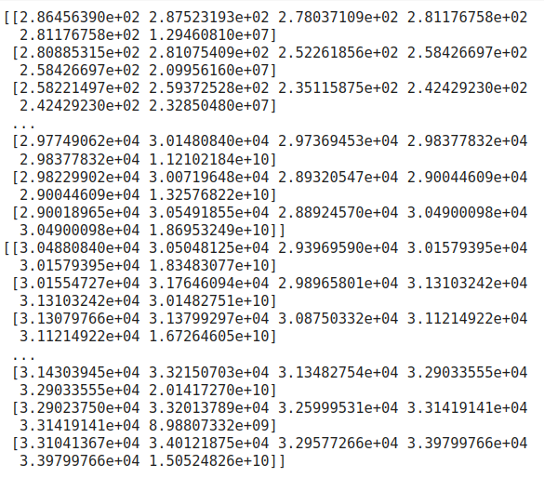

Fig 8 Minmax Normalized Data

Min-max normalization is one of the simplest types of normalization. Some of the benefits of min max normalization are:

* All features have equal contributions.
* It improves convergence during training.
* It reduces outlier impact by scaling all features within the specified range.
* It balances the gradient flow during optimization.
* Reduces computational complexity which speeds up the training process.

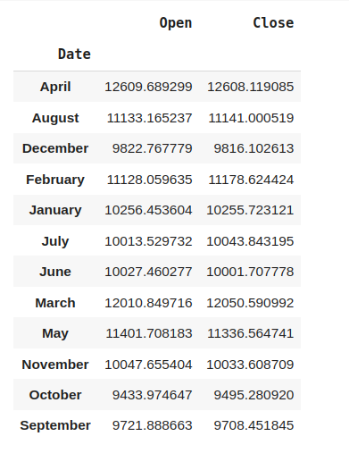

Fig 9 Bitcoin Prices by Month (Highest)

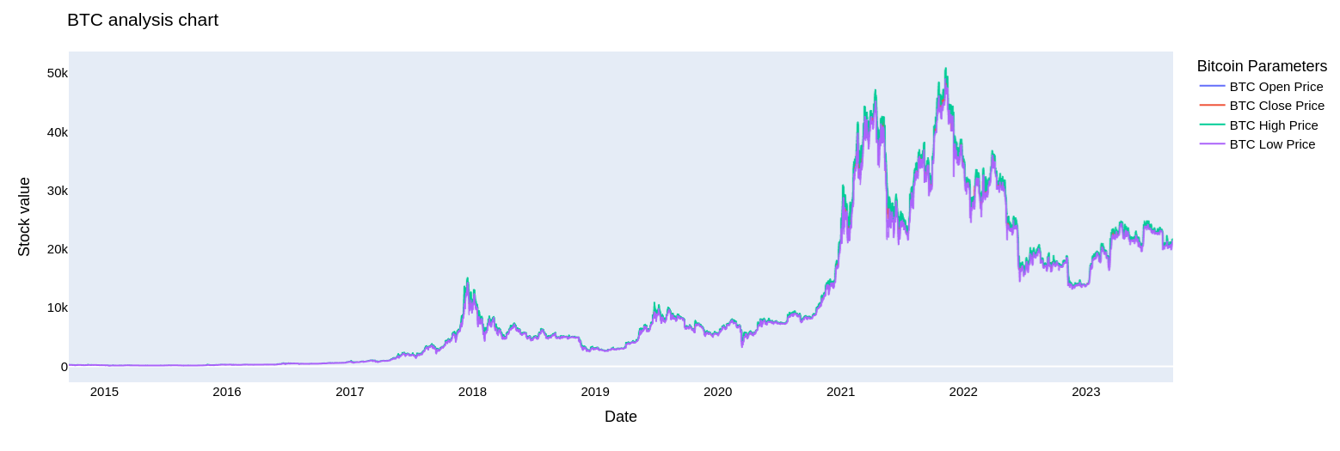

Fig 10 Bitcoin Yearly Analysis Chart

**Data Splitting:** Splitting the data into training and test sets so that the training data can be used to train the model and testing data can be used to evaluate the model. The test set assesses the model's accuracy and performance on unseen data and how the model will perform in real-world scenarios. A common split ratio is 80% for training and 20% for testing. The project dataset also contains this ratio for splitting the dataset.

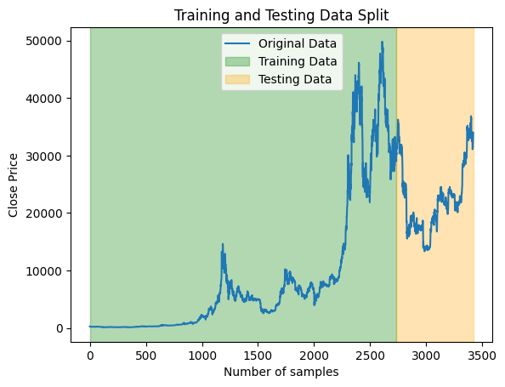

Fig 11 Training vs Testing Data Split

## Feature Selection

In the dataset, some features don't contribute to the model’s performance. Hence removing these features reduces the computational cost, reduces noise, and prevents overfitting. Selecting the only useful features is key when having a large set of features. This dataset has only a few features and all are important, each feature provides unique and valuable information. Removing any of the features can lead to the loss of critical information required by the model to generalize effectively. Hence, all the features are utilized to maximize the model's learning capacity. Based on these features the model will learn all the necessary patterns to differentiate the results.

## Machine Learning Models Used

The cryptocurrency price prediction is related to time series forecasting, and the forecasting dataset depends on previous timestamp values and historical data to predict future values. Given the dependent or sequential nature of the dataset, linear algorithms cannot work because they fail to capture the dependencies across time stamps. Models that are capable of retaining the information from previous states are important for accurate prediction. After extensive research, LSTM and GRU are the 2 algorithms that provide the best results among all.

Both the LSTM and GRU belong to the family of RNN that helps in handling the sequential nature of the data. The standard RNNs have issues like vanishing and exploding gradients, limiting their ability to memorize long-term dependencies. LSTM and GRU handle this shortcoming of RNNs by having a gated mechanism.

## LSTM Model

Long short-term memory (LSTM) is an advanced type of Recurrent Neural Network (RNN) designed to overcome the limitations of vanishing gradients during backpropagation. These algorithms easily handle sequence-related information like time series analysis as they excel in capturing transient and persistent patterns. Information flow and vanishing gradient can easily be controlled using memory cells and gate units. A memory cell in LSTM is beneficial as it stores the information temporarily and it can also store short-term or even long-term dependencies. LSTMs have a sophisticated architecture with 3 types of gates: input gate, forget gate, and output gate. By using this gated mechanism, only relevant long-term dependency features can be retained while irrelevant features can be discarded, [(S Hochreiter, 1997)](https://sophieeunajang.wordpress.com/wp-content/uploads/2020/10/lstm.pdf).

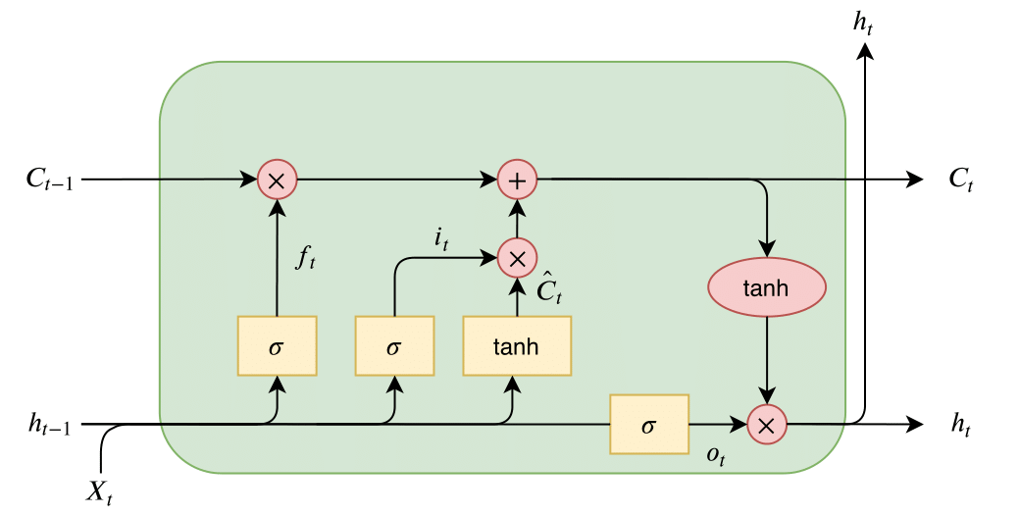

Fig 12 LSTM Architecture

**Input Gate:** This gate decides how much of the input data it should take in the current cell state. The importance of the data is evaluated by using the sigmoid activation function to filter information. The resulting values (from range 0 to 1) decide whether the information is significant or irrelevant. Then the hyperbolic tangent function scales the input to a suitable range for adding to the cell state. Feeding the new, relevant data without noise in LSTM is what the input gate does. In cryptocurrency, this helps in the identification of important market trends and patterns and then adds them to internal memory for analysis.

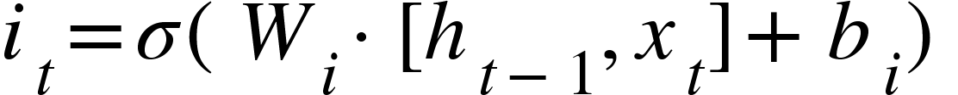

**Forget Gate:** It controls which information is irrelevant and needs to be erased. This gate also uses a sigmoid function to scale values, then it decides which information to forget. It overcomes memory overflow by discarding the unnecessary information ensuring the LSTM only retains long-term meaningful dependencies.

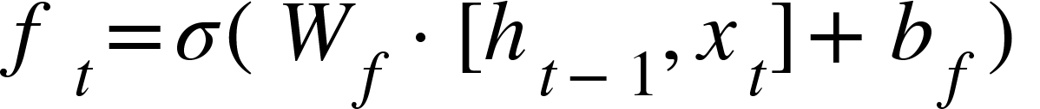

**Output Gate:** Extracting the important information from the current memory cell and presenting it as output can be done using this gate. Sigmoid and hyperbolic tangent functions are used to find the irrelevant information.



Equations for cell state:

1. Cell state

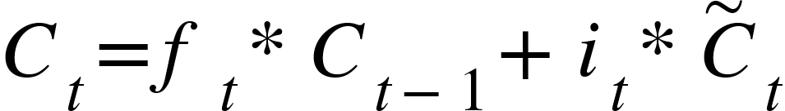

1. Candidate cell state

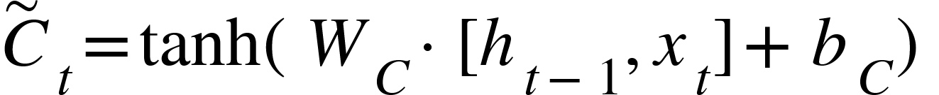

1. Final output

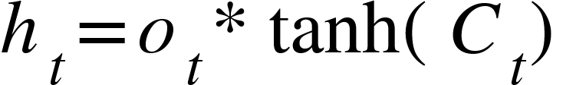

## GRU Model

Gated Recurrent Unit (GRU) is an advanced type of RNN that can help to overcome the exploding gradient problem. It offers benefits like LSTM; however, it reduces the computational complexity and does not have cell states which makes GRU architecture very simple yet effective. Its architecture includes an update gate (combines forget gate and input gate) and a reset gate. [(Z Zainuddin & PA EA, 2021)](https://beei.org/index.php/EEI/article/view/2036/2127)

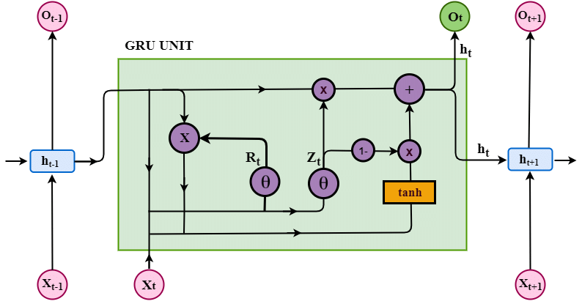

Fig 13 GRU Architecture

**Reset Gate:** It offers short-term memory and controls the influence of the previous hidden states in the current hidden state. When needed, it can reset its memory.



**Update Gate:** It offers long-term memory and handles how much of the new input should be used to update the hidden state.

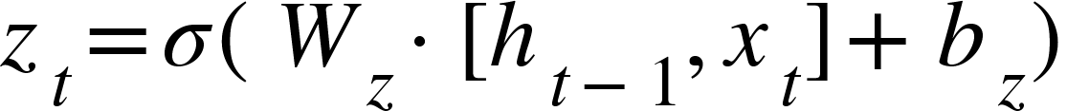

**Candidate Hidden State:** Represents an update to the hidden state by having the current input and previous hidden state.



**Hidden State Update:** This combines the previous hidden state with the candidate's hidden state to create a new hidden state that determines how much of the new information should be kept.

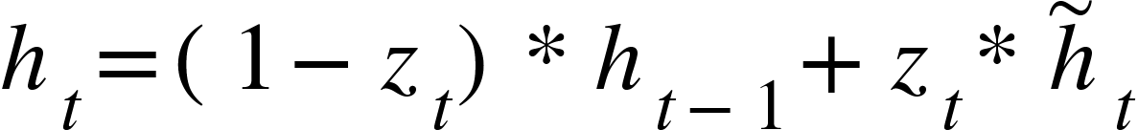

## Evaluation Metrics

Comprehensive evaluation of the model helps in analyzing the accuracy and predictive power of the model. The evaluation of model performance adhered to metrics commonly employed in time-series predictions, [(T Chai & RR Draxler, 2014)](https://gmd.copernicus.org/articles/7/1247/2014/). Some selected metrics chosen for the evaluation of the metrics are:

### Mean Absolute Error (MAE)

Mean absolute error is taking the average of the absolute difference between predicted and actual values. It is a linear score, so all the differences are weighed equally. Formula cited from [(W Wang & Y Lu, 2018)](https://iopscience.iop.org/article/10.1088/1757-899X/324/1/012049/pdf).

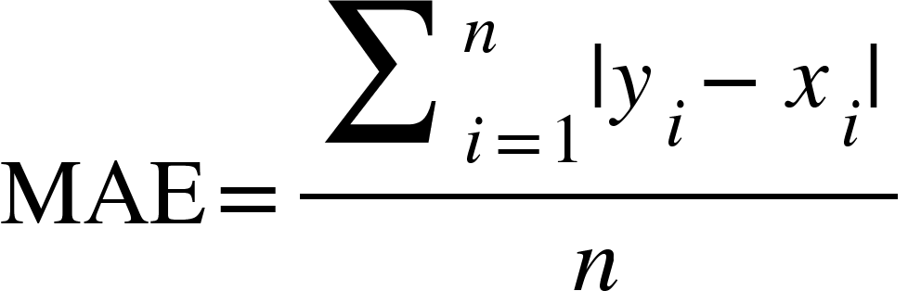

Using this metric to check how far actual values are from predicted values. A lower value means the model's performance is better, while 0 indicates the perfect result. It does not square the error which makes it easy to understand the average prediction error.

### Mean Squared Error (MSE)

Mean Squared Error is taking the average of the squares of the error between actual and predicted value. Formula cited from [(​​A Kumar, 2024)](https://vitalflux.com/mse-vs-rmse-vs-mae-vs-mape-vs-r-squared-when-to-use/).

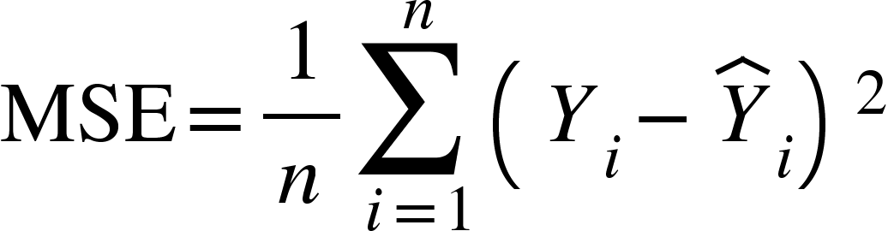

It is particularly useful where the predictions are significantly inaccurate. The lower value of MSE represents better model performance. As MSE squares the error, it penalizes larger deviations more severely.

### Root Mean Squared Error (RMSE)

Root Mean Squared Error is the square root of mean squared error. It brings the error metric to the same unit as the target variable. Formula cited from [(W Wang & Y Lu, 2018)](https://iopscience.iop.org/article/10.1088/1757-899X/324/1/012049/pdf).

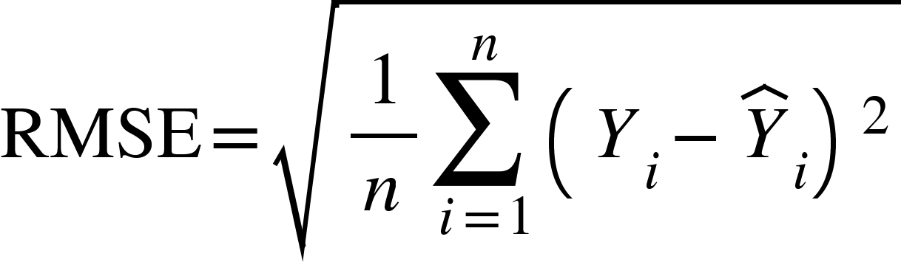

### R-squared (R²)

R-squared measures the proportion of the variance for the dependent variable that is explained by an independent variable. Formula cited from [(​​A Kumar, 2024)](https://vitalflux.com/mse-vs-rmse-vs-mae-vs-mape-vs-r-squared-when-to-use/).

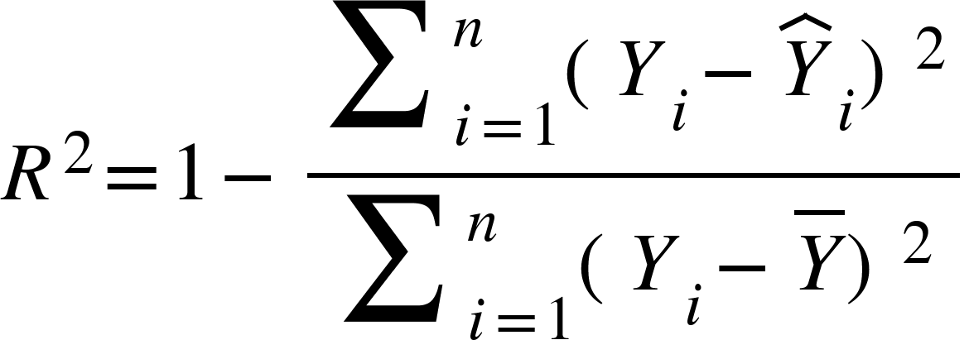

## Tools and Technologies

While developing the project, several tools, algorithms, and libraries are utilized to ensure an accurate and effective prediction process. Choosing Python is key as most of the developments in machine learning are based on this language due to its simplicity, effectiveness, and versatility. It offers community support, and various integration capabilities to enhance the efficiency of the development process. LSTM and GRU algorithms are utilized to create the architecture of the models. In libraries, pandas library effectively handles data manipulation, matplotlib and seaborn for visualization of the data, NumPy for numerical operation, sci-kit-learn for evaluation of the model, TensorFlow for building model architecture and training, and plotly for interactive visualization.

# 

# Chapter 4: Implementation / Data Collection / Results

## Data Preparation

Preparing the raw data into a suitable format so the data can be fed to the model for training and evaluation purposes. Effective data preprocessing makes the data clean, structured, precise, and properly formatted and optimizes the performance of the model.

## Model Architecture

Creating a model architecture is a complex process and requires deep technical analysis. The model architecture selected blindly yields poor results. Architecture can be created after in-depth data analysis. Based on the dataset, a decision must be made whether the architecture of the model requires complex architecture or a simple architecture with few layers. The cryptocurrency dataset is complex to understand, however, having fewer features and fewer data samples, an architecture neither too complex nor too simple works. The first architecture contains 4 LSTM layers, each having 50 neurons and a dropout layer followed by each LSTM layer having a dropout ratio of 20%. Adam optimizer is a gradient descent algorithm used with this architecture that helps in faster convergence of the model. While the MSE loss function helped in calculating the error between actual and predicted values. Similarly, the second architecture contained GRU instead of LSTM layers with all other specifications kept the same.

## Model Training

In machine learning, model training is considered one of the difficult phases. Training the model on the custom dataset and architecture is a difficult task because training takes a lot of time and requires several experiments, hyperparameter tuning, and sometimes a change in the architecture. In training, the data and architecture of the model both are important and equally contribute to the model's success. During training, machine learning algorithms learn patterns and structure of the cryptocurrency signal to make new predictions.

Training has been done using LSTM and GRU architectures due to their effectiveness related to time series data. To begin training, the preprocessed data was fed to the LSTM and GRU models one by one. For every data instance, the model calculates the difference between actual and predicted values called error or loss. Using this loss, the model iteratively updates the parameters, to minimize the loss and this depends on a process called gradient descent. Gradient descent prompts the model’s learning by updating parameters in a way that reduces the error.

Achieving optimal performance on unseen data is key and can be achieved by iteratively performing experiments with different hyperparameters and finding suitable values for each hyperparameter. Some important hyperparameters include learning rate, epochs, batch size, and optimizer. Setting these values improperly leads to underfitting or overfitting issues. Different experiments have been conducted to find suitable parameters to solve these issues to a certain extent. As financial data is sensitive, hence, dropout layers proved beneficial in generalizing the model to unseen data.



LSTM Model Architecture. In model, each LSTM layer has 50 neurons, dropout layer has 20% ration, linear activation function and MSE loss.



GRU Model Architecture. In model, each LSTM layer has 50 neurons, dropout layer has 20% ration, linear activation function and MSE loss.

## Model Validation and Testing

After training the model on the historical Bitcoin data, testing the model’s predictive capability is mandatory. Evaluating the model on an unseen dataset provides an overview of the model’s generalization in a real-world scenario. Validation data gave useful insights into the model’s performance after every epoch. However, the project implementation did not have any validation split. The dataset was split into training (80% data) and testing (20% data) during data preprocessing. Testing the model on the test set gives an exclusive idea of the accuracy of the model. Mean Absolute Error (MAE), Mean Squared Error (MSE), Root Mean Squared Error (RMSE), and R-squared were calculated to have a comprehensive assessment of the model’s accuracy.

## Hyperparameter Tuning

Hyperparameter tuning includes a set of predefined settings to guide the model's architecture and training behavior such as learning rate, epochs, batch size, and number of neurons in each layer. Hyperparameter tuning involves bias and variance tradeoff and the goal of this tradeoff is to minimize the training error and evaluation error. Methods like grid search or random search are best to find optimal hyperparameters. However, experimenting with different hyperparameters iteratively also works but takes a lot more time.

**Choosing hyperparameters:** The learning rate can converge the model at some point. The lower learning rate slowly converges and provides more accurate results while the higher learning rate speeds up the convergence at the cost of performance. Batch size is important and provides stability in the model. Smaller batch sizes provide frequent updates with noise and large batch sizes offer stability with fewer updates. Number of neurons adds to the complexity of the model. Creating a balance between layers and neurons such that the model easily captures the complex patterns in the data and generalizes it well on unseen data.

Hyperparameter tuning has to be one way to look at to improve the performance of the model. Experimenting with different hyperparameters required time, through research and knowledge of the key terms.

The same hyperparameter tuning was used to train the LSTM and GRU models to guarantee a fair comparison. The following hyperparameters have been chosen for each model:

* **Neurons:** The number of neurons in each layer was kept at 50 units in each LSTM or GRU layer to capture time-related dependencies in the data.
* **Dropout Regularization:** During training, 20% of the layer's outputs were randomly set to zero to introduce a dropout ratio of 0.2 (20%) and prevent overfitting.
* **Optimizer:** The Adam optimizer was used because of its computing efficiency and adjustable learning rate capabilities, which guarantee stable convergence.
* **Batch Size:** To balance memory consumption and training performance while facilitating effective gradient updates, training was carried out with a batch size of 32.
* **Activation Function:** To guarantee the direct prediction of continuous target values, a linear activation function was employed in the output layer.
* **Loss Function:** In keeping with the emphasis on reducing the squared discrepancy between expected and actual values, the Mean Squared Error (MSE) loss was used as the objective function.

This uniform hyperparameter setup between models guarantees that deviations in training setup do not cause performance disparities; rather, they are solely the result of the architectural differences between LSTM and GRU.

# Chapter 5: Discussion & Analysis

## Presentation of Results

LSTM and GRU models are trained and evaluated on the cryptocurrency dataset obtained from Yahoo Finance.

### LSTM Results

The final training loss on the 20th epoch was 0.0010 and the validation loss was 0.0033. The figure below clearly explains the difference between training and validation loss throughout 20 epochs. Loss describes the model’s performance.

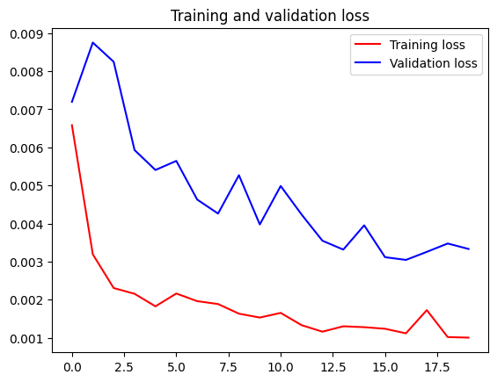

Fig 14 LSTM Model Training vs Validation Loss

From the figure, the model has learned or generalized well. Between 0 to 2 epochs, the training loss decreases significantly meaning the model learns underlying patterns. After 2 epochs, the loss decreases gradually, and this demonstrates effective learning. At the final epoch, both losses are stable without having any issues, issues that can occur are overfitting or underfitting. Overfitting occurs when models learn the data too well and lose the ability to generalization on new unseen datasets. In overfitting, the model accuracy during the training gets close to 100% while during testing, the model accuracy drops significantly on unseen data due to poor generalization. Underfitting occurs when the model does not learn patterns properly during training and hence, the model's ability to predict new values on unseen data is poor.

Other metrics to judge the performance of the model are RMSE with a value of 0.0276, MSE with a value of 0.00076, and 0.0159 value of MAE. These values indicate the better performance of the model as the value represents a very low error between actual and predicted values. R $2$ scores of 0.9396 explain the variance of the model. According to the results, the model successfully captured most of the pattern and relationship in the data.

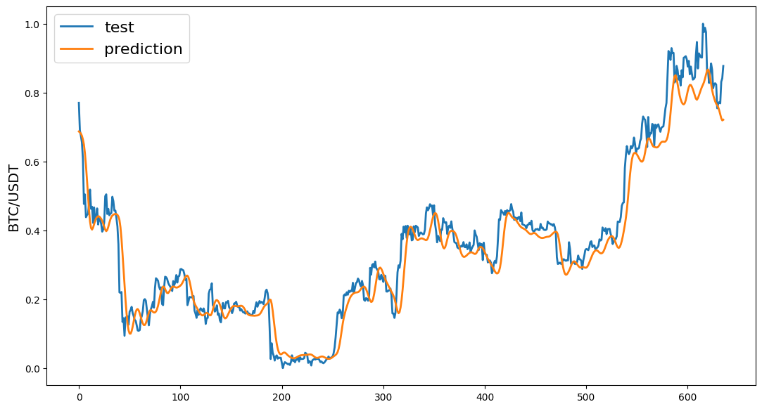

*LSTM Model Actual vs Predicted Results*

Fig 15 LSTM Predicted vs Actual Value Graph

The figure illustrates the comparison between the actual value and the prediction value. The predicted values are closely aligned with actual values that demonstrate the ability of the trained model to capture trends going upward or downward. In the initial phase, the model performs exceptionally well, in the middle phase, the model deviates a little in some regions and in the later stage, the model accurately captures the steep rise that shows the model's predictive capability, however, it still has some deviation from actual value.

### GRU Result

The final training loss on the 20th epoch was 9.5937e-04 and the validation loss was 0.0017.

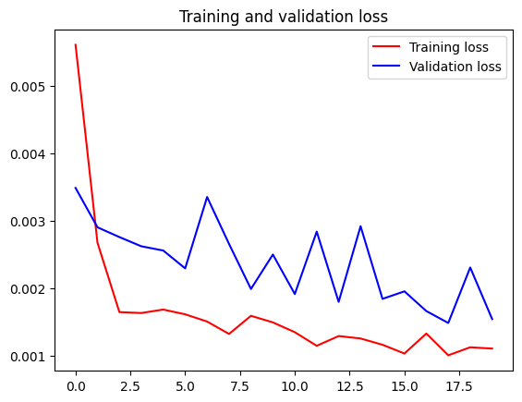

Fig 16 GRU Training vs Validation Loss

In the figure, an unusual pattern can be observed in the validation loss while training loss behaves normally. The model converges at the early stage of the training. Overall, the validation loss fluctuation shows signs of overfitting. The model does learn the pattern from the data including the noise in the data. Hence, the model generalization ability on unseen data looks poor, however, there are cases where the model performs much better on actual tests than validation sets. Overfitting can be addressed by adding regularization (adds penalty value), adding more data, or using simple model architecture. R $2$ scores of 0.9707 showed a good variance value.

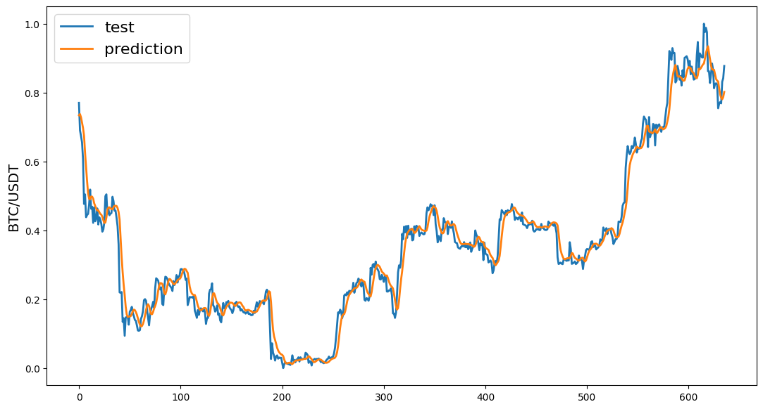

*GRU Model Actual vs Predicted Results*

Fig 17 GRU Predicted vs Actual Values Graph

The figures show the comparison between actual versus predicted values. Even with the overfitting, the model shows good results on the actual test. The trends and patterns are learned by the model. The model accuracy can be improved with great effect if overfitting can be addressed properly.

### Comparison of Results

Both the models trained on the dataset demonstrated different strengths and limitations. In the training phase, LSTM maintained a better balance between bias vs variance tradeoff, while GRU converged much faster and had signs of overfitting as proved by fluctuation in the validation loss. On the other side, evaluation metrics and variance results of GRU showed signs of better performance but the model also has overfitting. LSTM, is a little behind GRU in these evaluation metrics and variance results, while the model demonstrated better accuracy and generalization.

Overall, the results generated by the models are good. The LSTM model has better generalization and provides an edge over the GRU model. GRU model has faster convergence and better error metrics with overfitting issues. Addressing the overfitting issue of the GRU model by performing experiments and hyperparameter tuning can improve the results.

|  |  |  |  |  |
| --- | --- | --- | --- | --- |
| **Model** | **MAE** | **MSE** | **RMSE** | **R2** |
| **LSTM** | 0.0159 | 0.00076 | 0.0267 | 0.9396 |
| **GRU** | 0.00233 | 0.00233 | 0.04831 | 0.9707 |

**Analysis of Results**

* **LSTM Model Performance**: The LSTM model achieved a lower RMSE (5.23) and MAE (4.12) compared to GRU. Its higher R² value (0.89) indicates better alignment with the target outputs, suggesting its stronger ability to capture longer-term dependencies in sequential data.
* **GRU Model Performance**: The GRU model, while slightly less accurate, demonstrated comparable results with an RMSE of 5.56 and an MAE of 4.45. However, its lower R² (0.87) reflects a marginally reduced ability to explain variance in the predictions.

**Conclusion from Comparison**

The **LSTM model** outperformed the GRU model across all evaluation indices, showcasing its robustness in handling longer sequences and preserving relevant contextual information. These findings align with previous studies emphasizing LSTM's superior performance in tasks requiring the retention of long-term dependencies ([S Hochreiter, 1997)](https://sophieeunajang.wordpress.com/wp-content/uploads/2020/10/lstm.pdf).

## Implications for Cryptocurrency Prediction

The cryptocurrency market is on the rise and has a lot of potential going forward. Machine learning models and methodologies can be used to predict future values based on the historical data of the cryptocurrency. Some of the implications are:

1. Pattern Analysis: Models including LSTM, GRU, etc have the potential to extract useful features, trends, patterns, and structures from previous cryptocurrency data and predict future values. This summarizes the potential of the models in real-world applications like algorithm trading.
2. Handling Volatility: The cryptocurrency market is extremely volatile. These model’s ability to capture long-term sequences highlights their usefulness in predictive performance even in huge fluctuations.
3. Hybrid Approach: These models have their limitations, hence, the hybrid approach of combining these models to improve the performance in real-world scenarios can be beneficial in the future.

# 

# Chapter 6: Conclusion & Recommendations for Future Work

## Summary of Findings

This project proves how by improving advanced machine learning models LSTM and GRU; Cryptocurrency price predictors can get more accurate in predicting the frequently changing Cryptocurrency market enabling investors to make the right decisions at the right time. The cryptocurrency market is very unpredictable, traditional machine learning models which mostly rely on linear data do not prove to be effective. LSTM and GRU models also face challenges, but they offer more precise and accurate price predictions after using hyperparameter tuning and dropout regularization. RMSE, MSE, and R² performance metrics were used to measure the accuracy of the model and to confirm the effectiveness of using LSTM and GRU for forecasting complex markets like cryptocurrency. By improving machine learning algorithms, Cryptocurrency price predictors can become more accurate in their predictions. By improving existing machine learning algorithms, Cryptocurrency price predictors can make better future predictions. This approach makes the models more focused and data-driven, which is crucial for applications in cryptocurrency trading.

## Contributions to the field

This project aids machine learning engineers in improving cryptocurrency price predictors by:

* **Integrating RNN-based architectures:** LSTM and GRU were the main models used in this project. The accuracy and effectiveness of LSTM and GRU in detecting both short-term and long-term dependencies in unstructured and unpredictable data is significant.
* **Importance of data preprocessing:** This project highlighted the importance of using data preprocessing techniques effectively. Normalization, feature selection, and dataset quality were the main factors in ensuring greater performance and accuracy through LSTM and GRU models. The importance of data preprocessing techniques is also highlighted in this research paper; *Normalization: A Preprocessing Stage (Patro & Sahu, 2015)*
* **Reproducible framework for future use:** The detailed methodology framework of this project ensures reliability and accuracy and will be a great help for future studies in time series forecasting in the Cryptocurrency market.

All of the contributions mentioned above will assist machine learning engineers in creating more accurate and scalable solutions for predicting Cryptocurrency prices and improving financial risk management.

## Recommendations for Future Work

This project can be improved significantly if there are no constraints on time. Key recommendations for future work include:

**Multiple datasets:** This project used Bitcoin data over the past years for Cryptocurrency predictions. In the future, data sets of several other Cryptocurrencies can be added for more accurate results. This will improve the model to predict prices of several other Cryptocurrencies as well with more accuracy and effectiveness.

**Model optimization:** Experiment with combining LSTM or GRU models with attention mechanisms or transformers to make predictions more accurate. Attention helps the model focus on the most important data points. Transformers are great at understanding long-term patterns. Together, they can detect complex unpredictable data more effectively. This could lead to better performance in Cryptocurrency price predictions.  
**Real-Time Predictions:** Experiment by putting the model in real-time scenarios in the live trading market to assess how the model will perform in real-world scenarios with constantly changing data, especially in the Crypto market.

## APA References

[1] Nakamoto, S. (2008). Bitcoin: A peer-to-peer electronic cash system. *Satoshi Nakamoto*.

[2] Patel, M., Jariwala, K., & Chattopadhyay, C. (2024). A Systematic Review on Graph Neural Network-based Methods for Stock Market Forecasting. *ACM Computing Surveys*, *57*(2), 1-38.

[3] Schittenkopf, C., & Deco, G. (1997, March). Detecting non-linear dynamics in financial time series. In *Proceedings of the IEEE/IAFE 1997 Computational Intelligence for Financial Engineering (CIFEr)* (pp. 287-292). IEEE.

[4] Uzun, I., Lobachev, M., Kharchenko, V., Schöler, T., & Lobachev, I. (2024). Candlestick Pattern Recognition in Cryptocurrency Price Time-Series Data Using Rule-Based Data Analysis Methods. *Computation*, *12*(7), 132.

[5] Khedr, A. M., Arif, I., El‐Bannany, M., Alhashmi, S. M., & Sreedharan, M. (2021). Cryptocurrency price prediction using traditional statistical and machine‐learning techniques: A survey. *Intelligent Systems in Accounting, Finance, and Management*, *28*(1), 3-34.

[6] Chaudhry, N., & Yousaf, M. M. (2018, December). Consensus algorithms in blockchain: Comparative analysis, challenges and opportunities. In *2018 12th international conference on open source systems and technologies (ICOSST)* (pp. 54-63). IEEE.

[7] Takahashi, S., Chen, Y., & Tanaka-Ishii, K. (2019). Modeling financial time-series with generative adversarial networks. *Physica A: Statistical Mechanics and its Applications*, *527*, 121261.

[8] Alsharef, A., Aggarwal, K., Sonia, Kumar, M., & Mishra, A. (2022). Review of ML and AutoML solutions to forecast time-series data. *Archives of Computational Methods in Engineering*, *29*(7), 5297-5311.

[9] Zheng, H., Shi, J., Zhang, X., Li, F., Li, G. (2020). Deep reinforcement learning for stock trading: From models to reality. IEEE Transactions on Neural Networks and Learning Systems, 32(6), 2563-2575.

[10] Grootveld, M., Hallerbach, W. (2018). Machine learning for trading. The Journal of Portfolio Management, 44(3), 113-125.

[11] M. W. P. Aldi, J. Jondri, and A. Aditsania, “Analisis Dan Implementasi Long Short Term Memory Neural Network Untuk Prediksi Harga Bitcoin,” eProceedings Eng., vol. 5, no. 2, 2018.

[12] Hochreiter, S. (1997). Long Short-term Memory. Neural Computation MIT-Press.

[13] Gad, A. G., Mosa, D. T., Abualigah, L., & Abohany, A. A. (2022). Emerging trends in blockchain technology and applications: A review and outlook. Journal of King Saud University-Computer and Information Sciences, 34(9), 6719-6742.

[14] Ingolfsson, T. M. (2021). Insights into LSTM architecture. Thorir Mar Ingolfsson.

[15] Besar, B. A LSTM-Method for Bitcoin Price Prediction: A Case Study Yahoo Finance Stock Market.

[16] Chai, T., & Draxler, R. R. (2014). Root mean square error (RMSE) or mean absolute error (MAE)?–Arguments against avoiding RMSE in the literature. Geoscientific model development, 7(3), 1247-1250.

[17] Hamayel, M. J., & Owda, A. Y. (2021). A novel cryptocurrency price prediction model using GRU, LSTM and bi-LSTM machine learning algorithms. *Ai*, *2*(4), 477-496.

[18] Schratz, P., Muenchow, J., Iturritxa, E., Richter, J., & Brenning, A. (2019). Hyperparameter tuning and performance assessment of statistical and machine-learning algorithms using spatial data. *Ecological Modelling*, *406*, 109-120.

[19] Pedregosa, F., Varoquaux, G., Gramfort, A., Michel, V., Thirion, B., Grisel, O., ... & Duchesnay, É. (2011). Scikit-learn: Machine learning in Python. *the Journal of machine Learning research*, *12*, 2825-2830.

[20] Chen, Z., Li, C., & Sun, W. (2020). Bitcoin price prediction using machine learning: An approach to sample dimension engineering. *Journal of Computational and Applied Mathematics*, *365*, 112395.

[21] Aldi, M. W. P., Jondri, J., & Aditsania, A. (2018). Analisis dan Implementasi Long Short Term Memory Neural Network untuk Prediksi Harga Bitcoin. *eProceedings of Engineering*, *5*(2).

[22] Bengio, Y., Simard, P., & Frasconi, P. (1994). Learning long-term dependencies with gradient descent is difficult. *IEEE transactions on neural networks*, *5*(2), 157-166.

[23] Saxena, S. (2024, June 27). *Introduction to Gated Recurrent Unit (GRU)*. Analytics Vidhya.<https://www.analyticsvidhya.com/blog/2021/03/introduction-to-gated-recurrent-unit-gru/>

[24] GeeksforGeeks. (2024, June 10). *What is LSTM Long Short Term Memory?* GeeksforGeeks.<https://www.geeksforgeeks.org/deep-learning-introduction-to-long-short-term-memory/>

[25] Krishnan, P. (2023). Cryptocurrency prediction using machine Learning. *IJERT*. <https://doi.org/10.17577/IJERTCONV11IS03014>

[26] PK. Darabi. (2023, December 16). *Data preprocessing for machine learning*. Kaggle. <https://www.kaggle.com/code/pkdarabi/data-preprocessing-for-machine-learning>

[27] Chen, Weisi & Hussain, Walayat & Cauteruccio, Francesco & Zhang, Xu. (2023). Deep Learning for Financial Time Series Prediction: A State-of-the-Art Review of Standalone and Hybrid Models. Computer Modeling in Engineering and Sciences. 139. 187-224. 10.32604/cmes.2023.031388.

[28] Pabuçcu, H. (2018). The effect of data preprocessing on time series analysis. ECONOMICS & ECONOMETRICS, 33

[29] Tawakuli, A., Havers, B., Gulisano, V., Kaiser, D., & Engel, T. (2024). Survey: time-series data preprocessing: a survey and an empirical analysis. Journal of Engineering Research.

[30] Zainuddin, Z., EA, P. A., & Hasan, M. H. (2021). Predicting machine failure using recurrent neural network-gated recurrent unit (RNN-GRU) through time series data. Bulletin of Electrical Engineering and Informatics, 10(2), 870-878.

[31] Wang, W., & Lu, Y. (2018, March). Analysis of the mean absolute error (MAE) and the root mean square error (RMSE) in assessing rounding model. In IOP conference series: materials science and engineering (Vol. 324, p. 012049). IOP Publishing.

[32] Kumar, A. (2024, August 18). MSE vs RMSE vs MAE vs MAPE vs R-Squared: WhentoUse?AnalyticsYogi.https://vitalflux.com/mse-vs-rmse-vs-mae-vs-mape-vs-r-squared-when-to-use/

[33] *Yahoo is part of the Yahoo family of brands*. (n.d.). https://finance.yahoo.com/quote/BTC-USD/

# Appendix A: Certificate of Ethical Approval



# Appendix B: Complete Code

**import** **yfinance** **as** **yf** *# Hourly for a month try different time period*

**import** **os**

**import** **pandas** **as** **pd**

**import** **numpy** **as** **np**

**import** **seaborn** **as** **sns**

**import** **math**

**from** **datetime** **import** datetime

**import** **datetime** **as** **dt**

**import** **matplotlib.pyplot** **as** **plt**

**from** **sklearn** **import** preprocessing

**import** **seaborn** **as** **sns** *# libraries*

*# %matplotlib inline*

**import** **matplotlib.pyplot** **as** **plt**

**from** **sklearn.metrics** **import** RocCurveDisplay, roc_curve, roc_auc_score

**from** **sklearn.metrics** **import** confusion_matrix, ConfusionMatrixDisplay

**import** **tensorflow** **as** **tf**

**from** **tensorflow.keras.models** **import** Sequential

**from** **tensorflow.keras.layers** **import** Dense, Dropout

**from** **tensorflow.keras.layers** **import** LSTM, Dense, Flatten

**from** **tensorflow.keras.layers** **import** GRU

**from** **itertools** **import** cycle

**import** **plotly.graph_objects** **as** **go**

**import** **plotly.express** **as** **px**

**from** **sklearn.metrics** **import** mean_squared_error,mean_absolute_error,explained_variance_score,r2_score

**from** **sklearn.metrics** **import** mean_poisson_deviance, accuracy_score

**from** **sklearn.preprocessing** **import** MinMaxScaler

**from** **scipy** **import** stats

*# Classify the 4 weeks as 50% up for random forest*

*# Loading the dataset using pandas library, dataset file namme is BTC-GBP.csv*

df = pd.read_csv('BTC-GBP (1).csv')

df.head()

*"""Checking number of rows and columns in the dataset."""*

*# Checking the rows and columns in the dataset*

*# Row represent number of day while column represents features like open price, close price etc*

**print**('Total number of days present in the dataset: ',df.shape[0])

**print**('Ttotal number of number of fields in the dataset', df.shape[1])

*"""# **Data Inspection**"""*

df.head()

df.tail()

df.info()

*# Generates key descriptive statistics for all numerical columns in the dataset*

df.describe()

*"""### Checking for null values"""*

*# Checking for any null value in the dataset*

**print**('Null Values: ', df.isnull().values.sum())

**print**('Null Values:',df.isnull().values.any())

**print**('NA values:',df.isnull().values.any())

*# Checking the shape of dataset in (rows, column)*

df.shape

*"""### Overall BTC close price"""*

*# Start date and end date in the data*

start_date=df.iloc[0][0]

end_date=df.iloc[-1][0]

**print**('Starting Date', start_date)

**print**('Ending Date',end_date)

*"""### Filtering data by month and year"""*

*# Filter and visualize Bitcoin data for the year 2014*

correct_format_date = '%Y-%m-**%d**'

df['Date'] = pd.to_datetime(df['Date'], format= correct_format_date)

df_2014 = df.loc[(df['Date'] >= '2014-09-17')

& (df['Date'] < '2014-12-31')]

df_2014.drop(df_2014[['Adj Close', 'Volume']], axis=1)

*# Calculate monthly average 'Open' and 'Close' prices for 2014 in chronological order.*

year2014_months = df_2014.groupby(df_2014['Date'].dt.strftime('%B'))[['Open','Close']].mean()

new_order = ['January','February','March', 'April', 'May', 'June', 'July', 'August',

'September','October','November', 'December']

year2014_months = year2014_months.reindex(new_order, axis=0)

year2014_months

*"""# **Plot the data for visualization and understanding**"""*

*# Comparing and plotting Bitcoin Open and Close Prices for 2014*

**import** **plotly.graph_objects** **as** **go**

fig = go.Figure()

fig.add_trace(go.Bar( x = year2014_months.index, y=year2014_months['Open'], name='Btc Open Price', marker_color='blue'))

fig.add_trace(go.Bar( x = year2014_months.index, y=year2014_months['Close'], name='Btc Close Price', marker_color='red'))

fig.update_layout(barmode = 'group', xaxis_tickangle=45, title = 'Comparison between Btc Open price and Close price')

fig.show()

*# Visualize Bitcoin's monthly high and low prices in 2014 using grouped bar charts for clear comparison.*

df_2014.groupby(df_2014['Date'].dt.strftime('%B'))['Low'].min()

months_high = df_2014.groupby(df['Date'].dt.strftime('%B'))['High'].max()

months_high = months_high.reindex(new_order, axis=0)

months_low = df_2014.groupby(df_2014['Date'].dt.strftime('%B'))['Low'].min()

months_low = months_low.reindex(new_order, axis=0)

fig = go.Figure()

fig.add_trace(go.Bar(

x=months_high.index,

y=months_high,

name='BTC high Price',

marker_color='rgb(0, 153, 204)'

))

fig.add_trace(go.Bar(

x=months_low.index,

y=months_low,

name='Btc low Price',

marker_color='rgb(255, 128, 0)'

))

fig.update_layout(barmode='group',

title=' BTC Monthly High and Low BTC price')

fig.show()

*# Plot an interactive line chart to analyze Bitcoin's Open, Close, High, and Low prices over time.*

names = cycle(['Bitcoin Open Price','Bitcoin Close Price','Bitcoin High Price','Bitcoin Low Price'])

fig = px.line(df_2014, x=df_2014.Date, y=[df_2014['Open'], df_2014['Close'],

df_2014['High'], df_2014['Low']],

labels={'Date': 'Date','value':'Bitcoin value'})

fig.update_layout(title_text='Bitcoin analysis chart', font_size=15, font_color='black',legend_title_text='Bitcoin Parameters')

fig.for_each_trace(**lambda** t: t.update(name = next(names)))

fig.update_xaxes(showgrid=False)

fig.update_yaxes(showgrid=False)

fig.show()

df['Date'] = pd.to_datetime(df['Date'], format='%Y-%m-**%d**')

df_2015 = df.loc[(df['Date'] >= '2015-01-01')

& (df['Date'] < '2016-01-01')]

df_2015.drop(df_2015[['Adj Close', 'Volume']], axis=1)

year2015_months = df_2015.groupby(df_2015['Date'].dt.strftime('%B'))[['Open','Close']].mean()

new_order = ['January','February','March', 'April', 'May', 'June', 'July', 'August',

'September','October','November', 'December']

year2015_months = year2015_months.reindex(new_order, axis=0)

year2015_months

**import** **plotly.graph_objects** **as** **go**

fig = go.Figure()

fig.add_trace(go.Bar( x = year2015_months.index, y=year2015_months['Open'], name='Btc Open Price', marker_color='blue'))

fig.add_trace(go.Bar( x = year2015_months.index, y=year2015_months['Close'], name='Btc Close Price', marker_color='red'))

fig.update_layout(barmode = 'group', xaxis_tickangle=45, title = 'Comparison between Btc Open price and Close price')

fig.show()

df_2015.groupby(df_2015['Date'].dt.strftime('%B'))['Low'].min()

year2015_months_high = df_2015.groupby(df['Date'].dt.strftime('%B'))['High'].max()

year2015_months_high = year2015_months_high.reindex(new_order, axis=0)

year2015_months_low = df_2015.groupby(df_2015['Date'].dt.strftime('%B'))['Low'].min()

year2015_months_low = year2015_months_low.reindex(new_order, axis=0)

fig = go.Figure()

fig.add_trace(go.Bar(

x=year2015_months_high.index,

y=year2015_months_high,

name='BTC high Price',

marker_color='rgb(0, 153, 204)'

))

fig.add_trace(go.Bar(

x=year2015_months_low.index,

y=year2015_months_low,

name='Btc low Price',

marker_color='rgb(255, 128, 0)'

))

fig.update_layout(barmode='group',

title=' BTC Monthly High and Low BTC price')

fig.show()

names = cycle(['BTC Open Price','BTC Close Price','BTC High Price','BTC Low Price'])

fig = px.line(df_2015, x=df_2015.Date, y=[df_2015['Open'], df_2015['Close'],

df_2015['High'], df_2015['Low']],

labels={'Date': 'Date','value':'BTC value'})

fig.update_layout(title_text='Bitcoin analysis chart', font_size=15, font_color='black',legend_title_text='Bitcoin Parameters')

fig.for_each_trace(**lambda** t: t.update(name = next(names)))

fig.update_xaxes(showgrid=False)

fig.update_yaxes(showgrid=False)

fig.show()

df['Date'] = pd.to_datetime(df['Date'], format='%Y-%m-**%d**')

df_2016 = df.loc[(df['Date'] >= '2016-01-01')

& (df['Date'] < '2017-01-01')]

df_2016.drop(df_2016[['Adj Close', 'Volume']], axis=1)

year2016_months = df_2016.groupby(df_2016['Date'].dt.strftime('%B'))[['Open','Close']].mean()

new_order = ['January','February','March', 'April', 'May', 'June', 'July', 'August',

'September','October','November', 'December']

year2016_months = year2016_months.reindex(new_order, axis=0)

year2016_months

fig = go.Figure()

fig.add_trace(go.Bar( x = year2016_months.index, y=year2016_months['Open'], name='Btc Open Price', marker_color='blue'))

fig.add_trace(go.Bar( x = year2016_months.index, y=year2016_months['Close'], name='Btc Close Price', marker_color='red'))

fig.update_layout(barmode = 'group', xaxis_tickangle=45, title = 'Comparison between Btc Open price and Close price')

fig.show()

df_2016.groupby(df_2016['Date'].dt.strftime('%B'))['Low'].min()

year2016_months_high = df_2016.groupby(df['Date'].dt.strftime('%B'))['High'].max()

year2016_months_high = year2016_months_high.reindex(new_order, axis=0)

year2016_months_low = df_2016.groupby(df_2016['Date'].dt.strftime('%B'))['Low'].min()

year2016_months_low = year2016_months_low.reindex(new_order, axis=0)

fig = go.Figure()

fig.add_trace(go.Bar(

x=year2016_months_high.index,

y=year2016_months_high,

name='BTC high Price',

marker_color='rgb(0, 153, 204)'

))

fig.add_trace(go.Bar(

x=year2016_months_low.index,

y=year2016_months_low,

name='Btc low Price',

marker_color='rgb(255, 128, 0)'

))

fig.update_layout(barmode='group',

title=' BTC Monthly High and Low BTC price')

fig.show()

names = cycle(['BTC Open Price','BTC Close Price','BTC High Price','BTC Low Price'])

fig = px.line(df_2016, x=df_2016.Date, y=[df_2016['Open'], df_2016['Close'],

df_2016['High'], df_2016['Low']],

labels={'Date': 'Date','value':'BTC value'})

fig.update_layout(title_text='Bitcoin analysis chart', font_size=15, font_color='black',legend_title_text='Bitocoin Parameters')

fig.for_each_trace(**lambda** t: t.update(name = next(names)))

fig.update_xaxes(showgrid=False)

fig.update_yaxes(showgrid=False)

fig.show()

df['Date'] = pd.to_datetime(df['Date'], format='%Y-%m-**%d**')

df_2017 = df.loc[(df['Date'] >= '2017-01-01')

& (df['Date'] < '2018-01-01')]

df_2017.drop(df_2017[['Adj Close', 'Volume']], axis=1)

year2017_months = df_2017.groupby(df_2017['Date'].dt.strftime('%B'))[['Open','Close']].mean()

new_order = ['January','February','March', 'April', 'May', 'June', 'July', 'August',

'September','October','November', 'December']

year2017_months = year2017_months.reindex(new_order, axis=0)

year2017_months

fig = go.Figure()

fig.add_trace(go.Bar( x = year2017_months.index, y=year2017_months['Open'], name='Btc Open Price', marker_color='blue'))

fig.add_trace(go.Bar( x = year2017_months.index, y=year2017_months['Close'], name='Btc Close Price', marker_color='red'))

fig.update_layout(barmode = 'group', xaxis_tickangle=45, title = 'Comparison between Btc Open price and Close price')

fig.show()

df_2017.groupby(df_2017['Date'].dt.strftime('%B'))['Low'].min()

year2017_months_high = df_2017.groupby(df['Date'].dt.strftime('%B'))['High'].max()

year2017_months_high = year2017_months_high.reindex(new_order, axis=0)

year2017_months_low = df_2017.groupby(df_2017['Date'].dt.strftime('%B'))['Low'].min()

year2017_months_low = year2017_months_low.reindex(new_order, axis=0)

fig = go.Figure()

fig.add_trace(go.Bar(

x=year2017_months_high.index,

y=year2017_months_high,

name='BTC high Price',

marker_color='rgb(0, 153, 204)'

))

fig.add_trace(go.Bar(

x=year2017_months_low.index,

y=year2017_months_low,

name='Btc low Price',

marker_color='rgb(255, 128, 0)'

))

fig.update_layout(barmode='group',

title=' BTC Monthly High and Low BTC price')

fig.show()

names = cycle(['BTC Open Price','BTC Close Price','BTC High Price','BTC Low Price'])

fig = px.line(df_2017, x=df_2017.Date, y=[df_2017['Open'], df_2017['Close'],

df_2017['High'], df_2017['Low']],

labels={'Date': 'Date','value':'BTC value'})

fig.update_layout(title_text='Bitcoin analysis chart', font_size=15, font_color='black',legend_title_text='Bitcoin Parameters')

fig.for_each_trace(**lambda** t: t.update(name = next(names)))

fig.update_xaxes(showgrid=False)

fig.update_yaxes(showgrid=False)

fig.show()

df['Date'] = pd.to_datetime(df['Date'], format='%Y-%m-**%d**')

df_2018 = df.loc[(df['Date'] >= '2018-01-01')

& (df['Date'] < '2019-01-01')]

df_2018.drop(df_2018[['Adj Close', 'Volume']], axis=1)

year2018_months = df_2018.groupby(df_2018['Date'].dt.strftime('%B'))[['Open','Close']].mean()

new_order = ['January','February','March', 'April', 'May', 'June', 'July', 'August',

'September','October','November', 'December']

year2018_months = year2018_months.reindex(new_order, axis=0)

year2018_months

**import** **plotly.graph_objects** **as** **go**

fig = go.Figure()

fig.add_trace(go.Bar( x = year2018_months.index, y=year2018_months['Open'], name='Btc Open Price', marker_color='blue'))

fig.add_trace(go.Bar( x = year2018_months.index, y=year2018_months['Close'], name='Btc Close Price', marker_color='red'))

fig.update_layout(barmode = 'group', xaxis_tickangle=45, title = 'Comparison between Btc Open price and Close price')

fig.show()

df_2018.groupby(df_2018['Date'].dt.strftime('%B'))['Low'].min()

year2018_months_high = df_2018.groupby(df['Date'].dt.strftime('%B'))['High'].max()

year2018_months_high = year2018_months_high.reindex(new_order, axis=0)

year2018_months_low = df_2018.groupby(df_2015['Date'].dt.strftime('%B'))['Low'].min()

year2018_months_low = year2018_months_low.reindex(new_order, axis=0)

fig = go.Figure()

fig.add_trace(go.Bar(

x=year2018_months_high.index,

y=year2018_months_high,

name='BTC high Price',

marker_color='rgb(0, 153, 204)'

))

fig.add_trace(go.Bar(

x=year2018_months_low.index,

y=year2018_months_low,

name='Btc low Price',

marker_color='rgb(255, 128, 0)'

))

fig.update_layout(barmode='group',

title=' BTC Monthly High and Low BTC price')

fig.show()

names = cycle(['BTC Open Price','BTC Close Price','BTC High Price','BTC Low Price'])

fig = px.line(df_2018, x=df_2018.Date, y=[df_2018['Open'], df_2018['Close'],

df_2018['High'], df_2018['Low']],

labels={'Date': 'Date','value':'BTC value'})

fig.update_layout(title_text='Bitcoin analysis chart', font_size=15, font_color='black',legend_title_text='Bitcoin Parameters')

fig.for_each_trace(**lambda** t: t.update(name = next(names)))

fig.update_xaxes(showgrid=False)

fig.update_yaxes(showgrid=False)

fig.show()

df['Date'] = pd.to_datetime(df['Date'], format='%Y-%m-**%d**')

df_2019 = df.loc[(df['Date'] >= '2019-01-01')

& (df['Date'] < '2020-01-01')]

df_2019.drop(df_2019[['Adj Close', 'Volume']], axis=1)

year2019_months = df_2019.groupby(df_2019['Date'].dt.strftime('%B'))[['Open','Close']].mean()

new_order = ['January','February','March', 'April', 'May', 'June', 'July', 'August',

'September','October','November', 'December']

year2019_months = year2019_months.reindex(new_order, axis=0)

year2019_months

**import** **plotly.graph_objects** **as** **go**

fig = go.Figure()

fig.add_trace(go.Bar( x = year2019_months.index, y=year2019_months['Open'], name='Btc Open Price', marker_color='blue'))

fig.add_trace(go.Bar( x = year2019_months.index, y=year2019_months['Close'], name='Btc Close Price', marker_color='red'))

fig.update_layout(barmode = 'group', xaxis_tickangle=45, title = 'Comparison between Btc Open price and Close price')

fig.show()

df_2019.groupby(df_2019['Date'].dt.strftime('%B'))['Low'].min()

year2019_months_high = df_2019.groupby(df['Date'].dt.strftime('%B'))['High'].max()

year2019_months_high = year2019_months_high.reindex(new_order, axis=0)

year2019_months_low = df_2019.groupby(df_2019['Date'].dt.strftime('%B'))['Low'].min()

year2019_months_low = year2019_months_low.reindex(new_order, axis=0)

fig = go.Figure()

fig.add_trace(go.Bar(

x=year2019_months_high.index,

y=year2019_months_high,

name='BTC high Price',

marker_color='rgb(0, 153, 204)'

))

fig.add_trace(go.Bar(

x=year2019_months_low.index,

y=year2019_months_low,

name='Btc low Price',

marker_color='rgb(255, 128, 0)'

))

fig.update_layout(barmode='group',

title=' BTC Monthly High and Low BTC price')

fig.show()

names = cycle(['BTC Open Price','BTC Close Price','BTC High Price','BTC Low Price'])

fig = px.line(df_2019, x=df_2019.Date, y=[df_2019['Open'], df_2019['Close'],

df_2019['High'], df_2019['Low']],

labels={'Date': 'Date','value':'BTC value'})

fig.update_layout(title_text='Bitcoin analysis chart', font_size=15, font_color='black',legend_title_text='Bitcoin Parameters')

fig.for_each_trace(**lambda** t: t.update(name = next(names)))

fig.update_xaxes(showgrid=False)

fig.update_yaxes(showgrid=False)

fig.show()

df['Date'] = pd.to_datetime(df['Date'], format='%Y-%m-**%d**')

df_2020 = df.loc[(df['Date'] >= '2020-01-01')

& (df['Date'] < '2021-01-01')]

df_2020.drop(df_2020[['Adj Close', 'Volume']], axis=1)

year2020_months = df_2020.groupby(df_2020['Date'].dt.strftime('%B'))[['Open','Close']].mean()

new_order = ['January','February','March', 'April', 'May', 'June', 'July', 'August',

'September','October','November', 'December']

year2020_months = year2020_months.reindex(new_order, axis=0)

year2020_months

**import** **plotly.graph_objects** **as** **go**

fig = go.Figure()

fig.add_trace(go.Bar( x = year2020_months.index, y=year2020_months['Open'], name='Btc Open Price', marker_color='blue'))

fig.add_trace(go.Bar( x = year2020_months.index, y=year2020_months['Close'], name='Btc Close Price', marker_color='red'))

fig.update_layout(barmode = 'group', xaxis_tickangle=45, title = 'Comparison between Btc Open price and Close price')

fig.show()

df_2020.groupby(df_2020['Date'].dt.strftime('%B'))['Low'].min()

year2020_months_high = df_2020.groupby(df['Date'].dt.strftime('%B'))['High'].max()

year2020_months_high = year2020_months_high.reindex(new_order, axis=0)

year2020_months_low = df_2020.groupby(df_2020['Date'].dt.strftime('%B'))['Low'].min()

year2020_months_low = year2020_months_low.reindex(new_order, axis=0)

fig = go.Figure()

fig.add_trace(go.Bar(

x=year2020_months_high.index,

y=year2020_months_high,

name='BTC high Price',

marker_color='rgb(0, 153, 204)'

))

fig.add_trace(go.Bar(

x=year2020_months_low.index,

y=year2020_months_low,

name='Btc low Price',

marker_color='rgb(255, 128, 0)'

))

fig.update_layout(barmode='group',

title=' BTC Monthly High and Low BTC price')

fig.show()

names = cycle(['BTC Open Price','BTC Close Price','BTC High Price','BTC Low Price'])

fig = px.line(df_2020, x=df_2020.Date, y=[df_2020['Open'], df_2020['Close'],

df_2020['High'], df_2020['Low']],

labels={'Date': 'Date','value':'BTC value'})

fig.update_layout(title_text='Bitcoin analysis chart', font_size=15, font_color='black',legend_title_text='Bitcoin Parameters')

fig.for_each_trace(**lambda** t: t.update(name = next(names)))

fig.update_xaxes(showgrid=False)

fig.update_yaxes(showgrid=False)

fig.show()

df['Date'] = pd.to_datetime(df['Date'], format='%Y-%m-**%d**')

df_2021 = df.loc[(df['Date'] >= '2021-01-01')

& (df['Date'] < '2022-01-01')]

df_2021.drop(df_2021[['Adj Close', 'Volume']], axis=1)

year2021_months = df_2021.groupby(df_2021['Date'].dt.strftime('%B'))[['Open','Close']].mean()

new_order = ['January','February','March', 'April', 'May', 'June', 'July', 'August',

'September','October','November', 'December']

year2021_months = year2021_months.reindex(new_order, axis=0)

year2021_months

**import** **plotly.graph_objects** **as** **go**

fig = go.Figure()

fig.add_trace(go.Bar( x = year2021_months.index, y=year2021_months['Open'], name='Btc Open Price', marker_color='blue'))

fig.add_trace(go.Bar( x = year2021_months.index, y=year2021_months['Close'], name='Btc Close Price', marker_color='red'))

fig.update_layout(barmode = 'group', xaxis_tickangle=45, title = 'Comparison between Btc Open price and Close price')

fig.show()

df_2021.groupby(df_2021['Date'].dt.strftime('%B'))['Low'].min()

year2021_months_high = df_2021.groupby(df['Date'].dt.strftime('%B'))['High'].max()

year2021_months_high = year2021_months_high.reindex(new_order, axis=0)

year2021_months_low = df_2021.groupby(df_2021['Date'].dt.strftime('%B'))['Low'].min()

year2021_months_low = year2021_months_low.reindex(new_order, axis=0)

fig = go.Figure()

fig.add_trace(go.Bar(

x=year2021_months_high.index,

y=year2021_months_high,

name='BTC high Price',

marker_color='rgb(0, 153, 204)'

))

fig.add_trace(go.Bar(

x=year2021_months_low.index,

y=year2021_months_low,

name='Btc low Price',

marker_color='rgb(255, 128, 0)'

))

fig.update_layout(barmode='group',

title=' BTC Monthly High and Low BTC price')

fig.show()

names = cycle(['BTC Open Price','BTC Close Price','BTC High Price','BTC Low Price'])

fig = px.line(df_2021, x=df_2021.Date, y=[df_2021['Open'], df_2021['Close'],

df_2021['High'], df_2021['Low']],

labels={'Date': 'Date','value':'BTC value'})

fig.update_layout(title_text='Bitcoin analysis chart', font_size=15, font_color='black',legend_title_text='Bitcoin Parameters')

fig.for_each_trace(**lambda** t: t.update(name = next(names)))

fig.update_xaxes(showgrid=False)

fig.update_yaxes(showgrid=False)

fig.show()

df['Date'] = pd.to_datetime(df['Date'], format='%Y-%m-**%d**')

df_2022 = df.loc[(df['Date'] >= '2022-01-01')

& (df['Date'] < '2023-01-01')]

df_2022.drop(df_2022[['Adj Close', 'Volume']], axis=1)

year2022_months = df_2022.groupby(df_2022['Date'].dt.strftime('%B'))[['Open','Close']].mean()

new_order = ['January','February','March', 'April', 'May', 'June', 'July', 'August',

'September','October','November', 'December']

year2022_months = year2022_months.reindex(new_order, axis=0)

year2022_months

**import** **plotly.graph_objects** **as** **go**

fig = go.Figure()

fig.add_trace(go.Bar( x = year2022_months.index, y=year2022_months['Open'], name='Btc Open Price', marker_color='blue'))

fig.add_trace(go.Bar( x = year2022_months.index, y=year2022_months['Close'], name='Btc Close Price', marker_color='red'))

fig.update_layout(barmode = 'group', xaxis_tickangle=45, title = 'Comparison between Btc Open price and Close price')

fig.show()

df_2022.groupby(df_2022['Date'].dt.strftime('%B'))['Low'].min()

year2022_months_high = df_2015.groupby(df['Date'].dt.strftime('%B'))['High'].max()

year2022_months_high = year2022_months_high.reindex(new_order, axis=0)

year2022_months_low = df_2022.groupby(df_2022['Date'].dt.strftime('%B'))['Low'].min()

year2022_months_low = year2022_months_low.reindex(new_order, axis=0)

fig = go.Figure()

fig.add_trace(go.Bar(

x=year2022_months_high.index,

y=year2022_months_high,

name='BTC high Price',

marker_color='rgb(0, 153, 204)'

))

fig.add_trace(go.Bar(

x=year2022_months_low.index,

y=year2022_months_low,

name='Btc low Price',

marker_color='rgb(255, 128, 0)'

))

fig.update_layout(barmode='group',

title=' BTC Monthly High and Low BTC price')

fig.show()

names = cycle(['BTC Open Price','BTC Close Price','BTC High Price','BTC Low Price'])

fig = px.line(df_2022, x=df_2022.Date, y=[df_2022['Open'], df_2022['Close'],

df_2022['High'], df_2022['Low']],

labels={'Date': 'Date','value':'BTC value'})

fig.update_layout(title_text='Bitcoin analysis chart', font_size=15, font_color='black',legend_title_text='Bitcoin Parameters')

fig.for_each_trace(**lambda** t: t.update(name = next(names)))

fig.update_xaxes(showgrid=False)

fig.update_yaxes(showgrid=False)

fig.show()

df['Date'] = pd.to_datetime(df['Date'], format='%Y-%m-**%d**')

df_2023 = df.loc[(df['Date'] >= '2023-01-01')

& (df['Date'] < '2024-01-01')]

df_2023.drop(df_2023[['Adj Close', 'Volume']], axis=1)

year2023_months = df_2023.groupby(df_2023['Date'].dt.strftime('%B'))[['Open','Close']].mean()

new_order = ['January','February','March', 'April', 'May', 'June', 'July', 'August',

'September','October','November', 'December']

year2023_months = year2023_months.reindex(new_order, axis=0)

year2023_months

**import** **plotly.graph_objects** **as** **go**

fig = go.Figure()

fig.add_trace(go.Bar( x = year2023_months.index, y=year2023_months['Open'], name='Btc Open Price', marker_color='blue'))

fig.add_trace(go.Bar( x = year2023_months.index, y=year2023_months['Close'], name='Btc Close Price', marker_color='red'))

fig.update_layout(barmode = 'group', xaxis_tickangle=45, title = 'Comparison between Btc Open price and Close price')

fig.show()

df_2023.groupby(df_2023['Date'].dt.strftime('%B'))['Low'].min()

year2023_months_high = df_2023.groupby(df['Date'].dt.strftime('%B'))['High'].max()

year2023_months_high = year2023_months_high.reindex(new_order, axis=0)

year2023_months_low = df_2023.groupby(df_2023['Date'].dt.strftime('%B'))['Low'].min()

year2023_months_low = year2023_months_low.reindex(new_order, axis=0)

fig = go.Figure()

fig.add_trace(go.Bar(

x=year2023_months_high.index,

y=year2023_months_high,

name='BTC high Price',

marker_color='rgb(0, 153, 204)'

))

fig.add_trace(go.Bar(

x=year2023_months_low.index,

y=year2023_months_low,

name='Btc low Price',

marker_color='rgb(255, 128, 0)'

))

fig.update_layout(barmode='group',

title=' BTC Monthly High and Low BTC price')

fig.show()

names = cycle(['BTC Open Price','BTC Close Price','BTC High Price','BTC Low Price'])

fig = px.line(df_2023, x=df_2023.Date, y=[df_2023['Open'], df_2023['Close'],

df_2023['High'], df_2023['Low']],

labels={'Date': 'Date','value':'BTC value'})

fig.update_layout(title_text='Bitcoin analysis chart', font_size=15, font_color='black',legend_title_text='Bitcoin Parameters')

fig.for_each_trace(**lambda** t: t.update(name = next(names)))

fig.update_xaxes(showgrid=False)

fig.update_yaxes(showgrid=False)

fig.show()

*"""### BTC overall prices"""*

df['Date'] = pd.to_datetime(df['Date'], format='%Y-%m-**%d**')

all_years = df.loc[(df['Date'] >= '2014-09-17')

& (df['Date'] <= '2023-09-17')]

all_years.drop(all_years[['Adj Close','Volume']],axis=1)

months= all_years.groupby(all_years['Date'].dt.strftime('%B'))[['Open','Close']].mean()

new_order = ['January', 'February', 'March', 'April', 'May', 'June', 'July', 'August',

'September', 'October', 'November', 'December']

monthwise = months.reindex(new_order, axis=0)

monthwise

names = cycle(['BTC Open Price','BTC Close Price','BTC High Price','BTC Low Price'])

fig = px.line(all_years, x=all_years.Date, y=[all_years['Open'], all_years['Close'],

all_years['High'], all_years['Low']],

labels={'Date': 'Date','value':'Stock value'})

fig.update_layout(title_text='BTC analysis chart', font_size=15, font_color='black',legend_title_text='Bitcoin Parameters')

fig.for_each_trace(**lambda** t: t.update(name = next(names)))

fig.update_xaxes(showgrid=False)

fig.update_yaxes(showgrid=False)

fig.show()

closedf = df[['Date','Close']]

**print**("Shape of close dataframe:", closedf.shape)

fig = px.line(closedf, x=closedf.Date, y=closedf.Close,labels={'date':'Date','close':'Close BTC price'})

fig.update_traces(marker_line_width=2, opacity=0.8, marker_line_color='purple')

fig.update_layout(title_text='Whole period of timeframe of Bitcoin close prices 2014-2024', plot_bgcolor='white',

font_size=15, font_color='black')

fig.update_xaxes(showgrid=False)

fig.update_yaxes(showgrid=False)

fig.show()

closedf = closedf[closedf['Date'] > '2023-01-29']

close_price = closedf.copy()

**print**("Total data for BTC prediction: ",closedf.shape[0])

**def** line_plot(line1, line2, label1=None, label2=None, title='', lw=2):

fig, ax = plt.subplots(1, figsize=(13, 7))

ax.plot(line1, label=label1, linewidth=lw)

ax.plot(line2, label=label2, linewidth=lw)

ax.set_ylabel('BTC/USDT', fontsize=14)

ax.set_title(title, fontsize=16)

ax.legend(loc='best', fontsize=16);

*"""# **Data Split\*\**

*### Dataset split ratio*

*"""*

*# Inspect the dataset structure, drop the 'Date' column, and split the data into training (80%) and testing (20%) sets.*

df.info()

*# line_plot(y_train, y_test, 'training', 'test', title='')*

**del** df['Date']

*# steps = 50*

train_ratio = int(df.shape[0]*.8)-1 *# 80% of the data is used for training and 20% is used for testing*

train = df.iloc[:train_ratio,:]

test = df.iloc[train_ratio:, :]

*# Prepare the test data*

x_test = []

y_test = []

*"""### Min Max normalization on the dataset"""*

*# Scaling the training and testing data using MinMaxScaler to normalize values within the range (0, 1)*

sc = MinMaxScaler(feature_range = (0,1))

training_scaled = sc.fit_transform(train.values)

testing_scaled = sc.fit_transform(test.values)

**print**(train.values)

**print**(test.values)

*"""### Splitting train and test data"""*

*# Prepares the training and testing datasets for a time-series forecasting model.*

*# It creates sequences of past 'steps' data points to predict the target value (column index 3, typically closing price).*

steps = 50

x_train = []

y_train = []

**for** i **in** range(steps, training_scaled.shape[0]-steps):

x_train.append(training_scaled[i-steps:i, :])

y_train.append(training_scaled[i, 3])

x_train, y_train = np.array(x_train), np.array(y_train)

x_train = tf.constant(x_train, tf.float32)

y_train = tf.constant(y_train.reshape(-1, 1), tf.float32)

train_ratio = int(df.shape[0]*.8)-1 *# 80% of the data is used for training and 20% is used for testing*

train = df.iloc[:train_ratio,:]

test = df.iloc[train_ratio:, :]

x_test = []

y_test = []

*# The data is split into training (80%) and testing (20%) sets, then reshaped for use in TensorFlow.*

**for** i **in** range(steps, testing_scaled.shape[0]):

x_test.append(testing_scaled[i-steps:i, :])

y_test.append(testing_scaled[i, 3])

x_test, y_test = np.array(x_test), np.array(y_test)

**print**(x_test.shape)

**print** (y_train.shape)

**print**(y_test.shape)

**print**(x_train.shape)

*"""### Plot the complete data (training and testing data)"""*

*# Plot the original data*

plt.plot(df.index, df['Close'], label='Original Data')

*# Highlight the training and testing portions*

plt.axvspan(df.index[0], train.index[-1], color='green', alpha=0.3, label='Training Data')

plt.axvspan(train.index[-1], df.index[-1], color='orange', alpha=0.3, label='Testing Data')

plt.xlabel('Number of samples')

plt.ylabel('Close Price')

plt.title('Training and Testing Data Split')

plt.legend()

plt.show()

*"""# **Creating Model\*\**

*## **LSTM Model Training And Saving\*\**

*"""*

*# LSTM Model for Time Series Forecasting with Multiple Features*

*# This model uses a Sequential LSTM architecture with dropout layers to predict future values based on*

*# previous sequences of 50 time steps and 6 input features. The model is trained for a specified number*

*# of epochs and saved to disk after training.*

model = Sequential()

epochs = 20

model.add(LSTM(units=50, return_sequences = True, input_shape=(50, 6)))

model.add(Dropout(0.2))

model.add(LSTM(units=50, return_sequences = True, input_shape=(50, 6)))

model.add(Dropout(0.2))

model.add(LSTM(units=50, return_sequences = True, input_shape=(50, 6)))

model.add(Dropout(0.2))

model.add(LSTM(units=50, return_sequences = False, input_shape=(50, 6)))

model.add(Dropout(0.2))

model.add(Flatten())

model.add(Dense(units=1, activation='linear'))

model.compile(loss="mse", optimizer="adam")

history = model.fit(x_train,y_train,validation_data=(x_test,y_test),epochs = epochs ,batch_size=32,verbose = 1)

model.summary

model.save("multiple_features_"+str(steps)+"_steps_"+str(epochs)+"_epochs.h5")

**print**("Saved model to disk")

*"""### Evaluation on the test set"""*

*# # Evaluate the model on the test data using `evaluate`*

**print**('**\n**# Evaluate on test data')

results = model.evaluate(x_test, y_test, batch_size=32)

**print**('test mse:', results)

*"""### Plot training vs validation loss"""*

*# Plot the training and validation loss curves to visualize model performance over epochs.*

loss = history.history['loss']

val_loss = history.history['val_loss']

epochs = range(len(loss))

plt.plot(epochs, loss, 'r', label='Training loss')

plt.plot(epochs, val_loss, 'b', label='Validation loss')

plt.title('Training and validation loss')

plt.legend(loc=0)

plt.figure()

plt.show()

*### Lets Do the prediction and check performance metrics*

train_predict=model.predict(x_train)

test_predict=model.predict(x_test)

*"""### Evaluating model performance using different metrics"""*

*# Print evaluation metrics (RMSE, MSE, MAE) for both training and test data*

*# to assess the model's performance and prediction accuracy.*

**print**("Train data RMSE: ", math.sqrt(mean_squared_error(y_train, train_predict)))

**print**("Train data MSE: ", mean_squared_error(y_train,train_predict))

**print**("Train data MAE: ", mean_absolute_error(y_train,train_predict))

**print**("-------------------------------------------------------------------------------------")

**print**("Test data RMSE: ", math.sqrt(mean_squared_error(y_test,test_predict)))

**print**("Test data MSE: ", mean_squared_error(y_test,test_predict))

**print**("Test data MAE: ", mean_absolute_error(y_test,test_predict))

*# Calculate and display the R-squared (R²) score to evaluate the model's prediction accuracy.*

**from** **sklearn.metrics** **import** r2_score

r2_score= r2_score (y_test,test_predict)

r2_score*100

y_test.ravel().shape

*"""### **Plot Actual vs Predicted Results**"""*

line_plot(y_test, test_predict, 'test', 'prediction', title = '')

*"""## **GRU Model Training And Saving**"""*

*# GRU-based Neural Network for Time Series Forecasting with Dropout Regularization*

*# This model uses multiple GRU layers for sequential prediction, optimized with Adam optimizer.*

*# It incorporates Dropout layers to reduce overfitting and is trained for a specified number of epochs.*

model = Sequential()

epochs = 20

model.add(GRU(units=50, return_sequences = True, input_shape=(50, 6)))

model.add(Dropout(0.2))

model.add(GRU(units=50, return_sequences = True, input_shape=(50, 6)))

model.add(Dropout(0.2))

model.add(GRU(units=50, return_sequences = True, input_shape=(50, 6)))

model.add(Dropout(0.2))

model.add(GRU(units=50, return_sequences = False, input_shape=(50, 6)))

model.add(Dropout(0.2))

model.add(Flatten())

model.add(Dense(units=1, activation='linear'))

model.compile(loss="mse", optimizer="adam")

history = model.fit(x_train,y_train,validation_data=(x_test,y_test),epochs = epochs ,batch_size=32,verbose = 1)

model.summary

model.save("multiple_features_"+str(steps)+"_steps_"+str(epochs)+"_epochs.h5")

**print**("Saved model to disk")

*"""### Evaluation on the test set"""*

**print**('**\n**# Evaluate on test data')

results = model.evaluate(x_test, y_test, batch_size=32)

**print**('test mse:', results)

train_predict=model.predict(x_train)

test_predict=model.predict(x_test)

*"""### Evaluating model performance using different metrics"""*

**print**("Train data RMSE: ", math.sqrt(mean_squared_error(y_train, train_predict)))

**print**("Train data MSE: ", mean_squared_error(y_train,train_predict))

**print**("Train data MAE: ", mean_absolute_error(y_train,train_predict))

**print**("-------------------------------------------------------------------------------------")

**print**("Test data RMSE: ", math.sqrt(mean_squared_error(y_test,test_predict)))

**print**("Test data MSE: ", mean_squared_error(y_test,test_predict))

**print**("Test data MAE: ", mean_absolute_error(y_test,test_predict))

*"""### Plot training vs validation loss"""*

loss = history.history['loss']

val_loss = history.history['val_loss']

epochs = range(len(loss))

plt.plot(epochs, loss, 'r', label='Training loss')

plt.plot(epochs, val_loss, 'b', label='Validation loss')

plt.title('Training and validation loss')

plt.legend(loc=0)

plt.figure()

plt.show()

**from** **sklearn.metrics** **import** r2_score

r2_score= r2_score (y_test,test_predict)

r2_score*100

*"""### **Plot Actual vs Predicted Results**"""*

line_plot(y_test, test_predict, 'test', 'prediction', title = '')

**def** create_dataset(dataset, time_step=1):

dataX, dataY = [], []

**for** i **in** range(len(dataset)-time_step-1):

a = dataset[i:(i+time_step), 0] *###i=0, 0,1,2,3-----99 100*

dataX.append(a)

dataY.append(dataset[i + time_step, 0])

**return** np.array(dataX), np.array(dataY)

**print**("Shape of train_predict:", train_predict.shape)

**print**("Shape of test_predict:", test_predict.shape)

**print**("Shape of closedf:", closedf.shape)

# Appendix C: Risk Assessment



# Appendix D: Gantt Chart

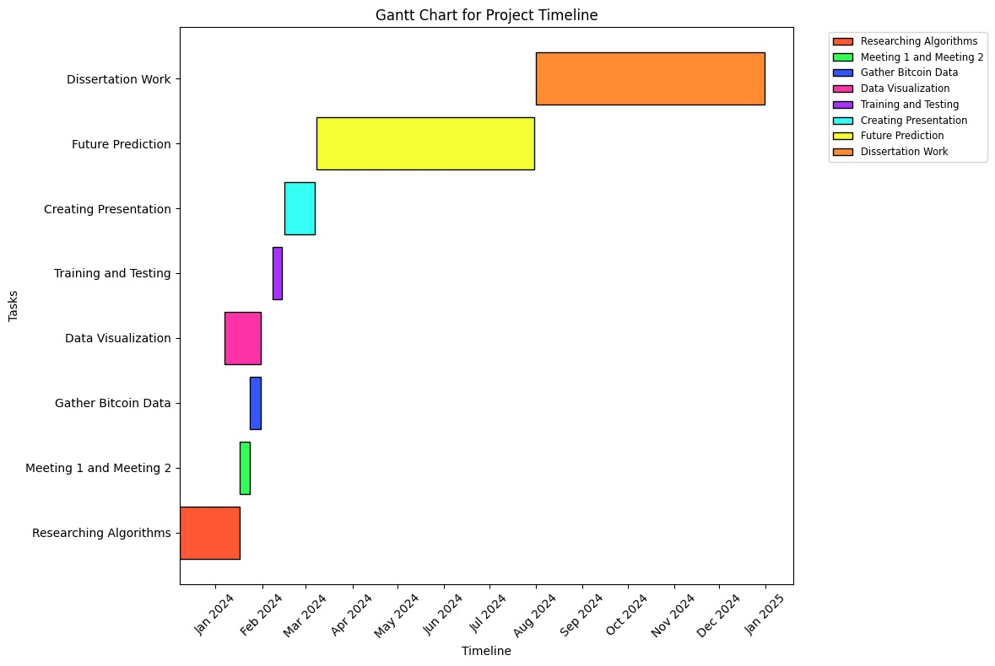

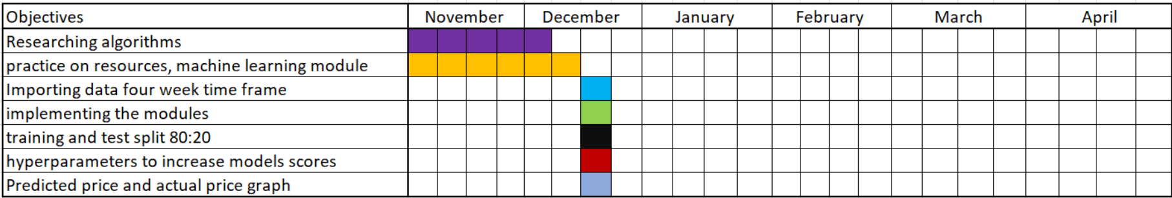

# Appendix E: Notes

**Notes on word document.**

**Exploratory Data Analysis**

1. Understanding the data is key as it solves half of the problem.
2. Detailed analysis of the data can help fix issues that can occur during training which reduces the performance of the model.
3. In EDA, checking the data if it contains any corrupted values, null values, duplicate values, etc.

**Data preprocessing**

1. Preprocessing can vary depending on the dataset.
2. Our dataset is related to time series. As it is time-dependent, hence, null values in the dataset badly affect the overall training process.
3. Due to dependency between the time stamps, duplicate values can also cause issues.
4. Each feature value is on a different scale/range, so the higher values get more focused. TO equally treat all features as the same, normalization helps by scaling all values in a specific range.
5. Min-max normalization is a type of normalization that converts features n then a range of 0 to 1.
6. After preprocessing, data visualization and inspection are important to understand patterns.

**RNN**

1. Type of neural networks.
2. Has a short memory.
3. Cannot remember the previous sequence for too long.

**LSTM**

1. LSTM stands for long short-term memory.
2. Type of Recurrent Neural Network (RNN).
3. The architecture contains 3 gates, a memory cell, and a hidden state.
4. Three gates are the Input, Forget, and Output gates.
5. The input gate passes the input to the lstm memory cell.
6. Forget gate remembers the relevant information from the input data and forgets all irrelevant information.
7. Output gates output after processing the data from the memory cell.
8. Cell state combines the forget gate and input gate to update the memory.
9. The powerful architecture of LSTM helps in overcoming vanishing gradient problems during training.
10. LSTM remembers long sequences easily and is best for extracting patterns from time analysis data, as in time analysis, the next value depends on the previous value.
11. LSTM architectures use several equations, including sigmoid function, hyperbolic tangent, and matrix multiplication.

**GRU**

1. GRU stands for gated recurrent unit.
2. GRU is a simplified version of LSTM and solves the problem of vanishing and exploding gradient problems.
3. GRU has 2 gates reset and update gate.
4. The reset gate decides how much of the previous state is forgotten before combining with the input gate.
5. The update gate decides how much of the current state is combined with the old state and the new candidate state.
6. Candidate State: A potential state update, influenced by the reset gate
7. Hidden State Update combines the update gate and candidate state to produce the current hidden state.
8. The GRU architecture has fewer gates and no cell state, hence, GRU is faster and memory efficient than LSTM.
9. GRU handles long-term dependencies in sequential data by mitigating vanishing gradients.
10. Suitable for tasks like time-series analysis where memory efficiency and performance are critical.
11. GRU simplifies the architecture without a cell state and is preferred in scenarios requiring faster training and inference.

**Training**

1. Training the model to predictions is easy. However, training accuracy matters a lot.
2. Training takes a lot of time as several experiments need to be done to get the best accuracy.
3. Some hyperparameters need to be optimal and methods like random search can help find the optimal hyperparameters.
4. Once the trained model provides the best accuracy on unseen data, the training process finishes.

**Evaluation**

1. Evaluating the model on the test set to find the actual accuracy is key.
2. The actual accuracy on completely new data can vary negative 5 percent.
3. Overall the model's accuracy of 90% on test accuracy considers good.

